NEEDS ASSESSMENT REPORT
2023 AMENDMENT
Updated January 23, 2024

Pennsylvania
Family Support
Programs
Original Fall 2020
Amended Winter 2023

Contents
Executive Summary 3
Preface 5
Introduction 7
Coordinating with the Title V Maternal and Child Health Block Grant, Head Start
and Child Abuse Prevention and Treatment Act Needs Assessment 7
Summary of Methods 11

2020 DOMAINS
Domain 1: Maternal & Child Health 17
Domain 2: Substance Use 19
Domain 3: Socioeconomic Status 24
Domain 4: Child Safety & Maltreatment 27
Domain 5: Community Environment 30
Domain 6: Child Care 33

Quality and Capacity of Existing Services 34
Summary of Administrative Survey Results 38
Community Survey 41

2023 NEEDS ASSESSMENT AMENDMENT DATA
2023 Need (Risk) Factors 45
2023 Summary of Overall Need (Risk) for Additional 22 Counties 45
2023 Summary of EBHV Capacity 47
2023 Summary of capacity for providing substance abuse treatment and counseling services 47
2023 References 50

2020 DOMAINS AND 2023 DATA
2020 and 2023 References

2020 APPENDIX*
1 – 2020 Domain Indicators by County
2 – 2020 County Profiles
3 – 2020 Sub-county Analyses
4 – 2020 Indicator Descriptions
5 – 2020 Additional Promising Practices
6 – 2020 Pennsylvania Home Visiting Program Capacity
7 – 2020 Additional Community and Administrative Survey Results
8 – 2020 Administrative and Community Surveys
9 – 2020 OUD Interim Summary

*The 2020 appendices are not included in the 2023 Amendment but can be viewed in the original 2020 submission.

2023 APPENDIX
1 – 2023-1 – Updated At-Risk Counties (Table 7 per HRSA)
2 – 2023-2 – Updated 2023 Amendment Needs Assessment Data (Need [Risk] Factors) Tables
3 – 2023-3 – EBHV Services and Gaps

Executive Summary
In 2020 states receiving federal Maternal, Infant, and Early Childhood Home Visiting (MIECHV) dollars were required to complete a statewide needs assessment in accordance with guidance from the Maternal and Child Health Bureau and the Administration for Children and Families. PolicyLab, a center of emphasis within the Research Institute of Children’s Hospital of Philadelphia, collaborated with the Pennsylvania Office of Child Development and Early Learning (OCDEL) to complete the 2020 Family Support Needs Assessment to meet this requirement.

The original report dated Fall 2020 presents a county-level assessment of the health of children, mothers, and families, as well as the social and environmental circumstances of families and communities in the state, including capacity for delivery of home visiting services utilizing data prior to the COVID-19 Public Health Emergency. We (OCDEL and CHOP PolicyLab) conducted the original needs assessment process over the period of January 2019 to October 2020, utilizing multiple methods of data collection, prioritizing a strengths-based, stakeholder-informed approach, and infusing community voices. In 2023, OCDEL was provided with the opportunity to amend the Needs Assessment to identify additional communities with concentrations of need by county.

NEEDS ASSESSMENT OBJECTIVES:
- Identify communities across the state with concentrations of need. In the original 2020 Needs Assessment, County Need was calculated across 6 domains comprised of 66 indicators designed to recognize the diversity of social and environmental factors affecting families with young children. The domains chosen were socioeconomic status, maternal and child health, substance use, community environment, child care, and child safety and maltreatment. This approach considers measures that reflect the impact of the social determinants of health, such as environmental quality, rent burden and food access, in addition to traditional measures of health outcomes and health care utilization. In the 2023 amendment, County Need was calculated across 22 need (risk) factors which identified counties with concentrations of need (risk), based on factors including: premature birth, low birth-weight infants, and infant mortality, including infant death due to neglect, and other indicators of at-risk prenatal, maternal, newborn, or child health; poverty; crime; domestic violence; high rates of high-school drop-outs; substance abuse; unemployment; and child maltreatment.

- Assess the capacity of existing home visiting programs within Pennsylvania’s counties and perceived accessibility of community social and health services. In 2020, Administrative and community surveys were conducted to explore the nuances of local program delivery, as well as community member perceptions of family needs and community resources. In the 2023 amendment, administrative data was utilized to address the existing capacity of services as of December 2022.

- Utilize a strengths-based approach to highlight innovative practices across the state. In the 2020 Needs Assessment, interviews and site visits were conducted to qualitatively investigate stakeholder-nominated practices that are re-shaping service delivery for children and families in local communities. Due to time constraints, a survey was not conducted for the 2023 Amendment.
2020 KEY FINDINGS
- Between fiscal years 2016-17 and 2019-20, the state increased its investment in evidence-based home visiting (EBHV) slots by 52% and expanded the availability of funds to support two additional EBHV models. In 2019-20, a total of 10,150 program slots were funded through the implementation of six different EBHV models to serve families across all 67 counties.
- The top three functions of home visiting services endorsed as most useful among nearly 300 home visited families surveyed were related to child development and early learning. Specifically, knowing if a child is growing or developing normally; age appropriate play, reading to or teaching children; and providing resources for pre-K or child care education.
- Since the 2014 statewide needs assessment, many of the 67 counties have seen substantive improvement (+5% relative change) on important metrics:
  - Nearly every county (63) saw improved rates of preterm birth and teen births
  - 60% of counties (40) saw improvements in infant mortality rates
  - Half of counties (32) saw a reduction in the percentage of children under age 5 living in poverty
- The analysis of county need found that one- third of Pennsylvania counties (23) did not meet the elevated need threshold for any of the six domains. Of the 44 counties reaching elevated need status in at least one domain, 15 met elevated need thresholds in three or more domains.
- The county-level availability and quality of health and social services for families of young children were perceived favorably by more than half of the 2,200 community survey respondents representing all 67 counties.
- Roughly 1 in 2 community survey respondents ranked the overall health of mothers and children in their community as excellent or good.
- The breadth of impact on issues related to substance use, mental health and intimate partner violence facing Pennsylvanian families of young children was clearly messaged from community members and home visiting administrators. Additional concerns regarding poverty, housing, employment, and child care remain elevated for many Pennsylvanian families.

2023 AMENDMENT KEY FINDINGS
- Between fiscal years 2020-2021 and 2023-2024 the state increased its investment in evidence-based home visiting (EBHV) by $18,601,786. The total state investment in EBHV for fiscal year 2023-2024 is $51,337,786. This is supplemented by an additional investment of $28,670,579 in federal funds for evidence-based home visiting, family support programs, and enhancements. For a total investment of $80,008,365.
- The analysis of the 2023 need (risk) factors reviewed showed that out of the 22 counties not currently eligible for MIECHV funding, prior to the submission of this amended needs assessment, 10 out of 22 counties were at above medium need level (risk) in at least 50% of the 22 need (risk) factors assessed.
- 18 of 22 counties were above the medium third of the 22 need (risk) factors assessed.
- All counties had an elevated need (risk) level in at least three of the need (risk) factors.
- Pennsylvania is requesting to add 22 counties to be eligible for MIECHV funding based on the need (risk) factors indicated for each county.

PREFACE
It is important to emphasize that the original data collection was completed for the 2020 Family Support Needs Assessment (“the Needs Assessment”) prior to the COVID-19 pandemic. While the information in this report provides a comprehensive review of county-level well-being across the state, it is likely that both acute and long-term effects of the pandemic will have exacerbated or altered needs within families and communities. Use of the data in the original 2020 needs assessment should occur in consideration of the impacts of COVID-19 on Pennsylvanian families and the early childhood service delivery landscape.

Families engaged in the state’s family support programming disproportionately live in under-resourced communities and inequitably experience social adversity. For these families, pandemic-related disruptions in employment and critical services such as child care and mental health or substance use treatment may create additional burden. Importantly, the state and local home visiting agencies worked together to maintain family support programming during the height of the pandemic’s initial phase and the corresponding stay-at-home orders, successfully delivering over 28,000 virtual visits between March 17 and June 5, 2020. While services transitioned to telephone and telehealth mechanisms, at its core, home visiting is built upon the connection between the home visitor and client in a familiar environment; the loss of this tangible connection is likely to be felt by both home visitors and families alike. Early data, as of the submission of the original Needs Assessment, suggested that referrals among statewide programming for children and families were decreasing.

There are several areas of concern for families of young children that require ongoing monitoring and consideration in the aftermath of the COVID-19 pandemic, the information under the headers below utilized data available in 2020:

Grandparents as Caregivers: Changes in the social and economic context of families and communities across the state, in part due to the impacts of the opioid crisis, have resulted in an increased number of grandparents in primary caretaker roles. In Pennsylvania, 89,000 children were in the care of grandparents as of 2020. Older adults and those with health problems are at increased risk for contracting COVID-19. Already faced with added stress and financial challenges during a transition to a primary caretaker or significant child care role, grandparental caregivers are forced to confront a new dilemma: caring for their own health is directly at odds with caring for their grandchildren.

Child Care: Child care centers are vital to ensuring the safety and education of young children across the state, in addition to representing an important employment sector. Between 2018-19, there were 7,200 regulated child care providers and more than 85,000 children ages 0-5 enrolled in state-subsidized child care. Closures in response to the COVID-19 pandemic have presented significant financial hardships for many child care centers. Child care reopening’s are also fraught with financial strain and logistical complexities related to health and safety protocols.

Mental Health: The isolation and uncertainty associated with the ongoing pandemic has negative implications for the mental health of children and parents. Infants and young children are sensitive to the stress experienced by their caregivers, and may exhibit signs of distress in the wake of disrupted routines. Those who try to access treatment for mental health needs may face additional challenges. Nearly all 880 practices that participated in a National Council for Behavioral Health (2020) survey reported having reduced their operations. Smaller organizations have cancelled, rescheduled or turned away 36% of patients due to COVID-19. For new mothers, the effects of removing the crucial support provided by family and friends in a high-stress time, coupled with the lack of Postpartum depression and anxiety screening and treatment, could be especially dire. Families of racial and ethnic minority groups may face additional challenges in accessing mental health care. Black and Hispanic patients are less likely to receive culturally sensitive care, and more likely to receive poor-quality care when treated (McGuire & Miranda, 2014). Added complexities in seeking and delivering behavioral health care for children and adolescents with limited English proficiency often result in underutilization of mental health services for this critically important population (Ohtani et al., 2015; Yun et al., 2019).

Child Maltreatment: There is reason to believe that the profound effects of the pandemic on household functioning could lead to an uptick in child abuse. In the wake of threatened financial security, health and educational needs, families are experiencing high levels of stress with fewer supports. Vulnerable children are suddenly without the observant eyes of teachers, child care providers and other mandated reporters. In 2018, school employees were responsible for more than one-third of the nearly 40,000 reports made by mandated reporters to ChildLine, the state’s hotline for suspected child abuse. Furthermore, known child maltreatment risk factors—such as parents struggling with substance use, untreated mental health and intimate partner violence—are on the rise. Now more than six months into the pandemic, ChildLine calls per month have declined sharply since last spring (Public Media for Central Pennsylvania, 2020a), a trend that suggests the safety and well-being of children may be at risk (Public Media for Central Pennsylvania, 2020b).

Housing: Of the numerous hardships facing families during the pandemic, repercussions associated with housing security are among the most dire. Research shows that housing insecurity is linked to difficulties accessing health care and negative impacts on physical health, especially for children. Foreclosures damage families financially and hurt neighborhoods and communities. Evictions make it more difficult for individuals to secure future housing (Healthy People 2020). Historically, people of color are disproportionally impacted by the lack of safe and affordable housing in the U.S., and current data suggests that COVID-19 will widen this disparity (Greene & McCargo, 2020). Families with caregivers experiencing unemployment or reduced work hours are now struggling to buy groceries, pay utility bills, and make rent or mortgage payments. Across the nation, the number of households unable to pay their housing bills continues to climb. A survey of more than 4,000 people found that almost one-third of households (32%) had not made their full July housing payments. Missed payments were even more likely (over 40%) among low-income households (with an income of less than $25,000 annually) and individuals under the age of 30 (Apartment List Survey Data, 2020). In Pennsylvania, temporary protections are in place to prevent homeowners and renters from foreclosure or evictions. Even with these important supports, the preexisting affordable housing crisis will be compounded by the economic impact of COVID-19 to have long-term negative impacts for families.
Emerging data on the increase of families seeking public assistance shows that thousands of Pennsylvanians are enduring the economic effects of the COVID-19 crisis. (Pittsburgh Post-Gazette, 2020). From March-May, nearly 15,000 Pennsylvanian children have enrolled in the Children’s Health Insurance Program and enrollment in Medical Assistance (Medicaid) has increased by 62,000 people (a 2.2% increase) since February. Additionally, enrollment in the Supplemental Nutrition Assistance Program
(SNAP) has seen the most drastic increase, with 123,000 people (a 7.1% increase) enrolled since February 2020.

As demonstrated in the original 2020 Needs Assessment report that follows, prepandemic data suggest that communities, and the state as a whole, are struggling with needs related to adequate and accessible child care and mental health services. It is anticipated that COVID-19 will exacerbate these existing issues, in addition to the others outlined above, having the potential to widen long-standing health disparities. The priority areas described in this section are only a handful of the concerns affecting communities during the difficult and uncertain period of the COVID-19 Public Health Emergency.

2023 Amendment and the COVID-19 Public Health Emergency
For the 2023 Needs Assessment Amendment, Pennsylvania attempted to utilize the most recent public data available for all need (risk) factors. The data periods vary based on public availability. When available, Pennsylvania opted to use data collected after the year 2020 to better align with the current needs of the counties and to better reflect the impact of the COVID-19 Public Health Emergency.

2020 and 2023 Introduction
The Office of Child Development and Early Learning (OCDEL) is the lead agency administering the Maternal, Infant, and Early Childhood Home Visiting (MIECHV) Program in Pennsylvania. MIECHV funding supports voluntary, evidence-based home visiting services for at-risk pregnant people and parents with young children up to kindergarten entry. The MIECHV program is federally administered by the Health Resources and Service Administration (HRSA) Maternal and Child

Health Bureau (MCHB) in partnership with the Administration for Children and Families (ACF).
In 2020, this federal funding supported four evidence-based home visiting programs across the state: Early Head Start; Healthy Families America; Nurse-Family Partnership; and Parents as Teachers. Additionally, two EBHV programs were supported through state funding Family Check-Up and SafeCare Augmented.

As of 2023, the federal MIECHV funding supported six evidence-based home visiting programs models, which include: Parents as Teachers, Nurse-Family Partnership, SafeCare Augmented, Early Head Start, Child First, and Family Check-Up. Eight models are supported by state and other federal funds, which include: Parents as Teachers, Nurse-Family Partnership, SafeCare Augmented, Early Head Start, Child First, Family Check-Up, Family Connects, and Healthy Families America.

As a requirement of continued funding, each MIECHV state, territory, or tribal grantee was tasked with completing a comprehensive needs assessment in 2020 to continually monitor the needs of families, identify gaps in the early childhood service system, and assess quality and capacity of existing home visitation programming within communities.

OCDEL contracted with PolicyLab at Children’s Hospital of Philadelphia to conduct the 2020 Pennsylvania Family Support Needs Assessment. In 2020 we chose an independent method to capture a comprehensive picture of need and opportunity in a geographically diverse state.

The 2020 needs assessment was designed as a public health tool offering a systematized way to identify geographic areas of elevated need and disparity to inform future decision-making and deploy resources to improve maternal, child, and family health and well-being. Community health is shaped by many determinants including structural, financial, political, environmental, cultural and social factors. Accordingly, this needs assessment examines a broad-ranging set of determinants of health, and seeks to acknowledge racial inequities and geographic disparities in health influenced by deep-rooted structural issues in our nation and state, including structural racism.

Given the breadth of their programming, OCDEL expanded the scope of this assessment to include all OCDEL-administered Family Support programs to create this Family Supports Needs Assessment (hereinafter “the Needs Assessment”). Beyond MIECHV, Family Support programs include additional EBHV models not funded through MIECHV, Family Centers, Parenting Classes and Fatherhood Programs.

By including metrics relevant to all Family Support programming in 2020, the Needs Assessment more accurately described the landscape of needs, service opportunities and community strengths for families of young children.

The 2020 Needs Assessment presents a county level assessment of the health of children, mothers and families, as well as the social and environmental circumstances of families and communities, in the state, including capacity for delivery of home visiting services. Between September 2018 and January 2019, PolicyLab and OCDEL engaged key state, local, and national stakeholders to assess their priorities and desired strategic direction for the metrics and information included in the Needs Assessment. Following this preliminary phase, the needs assessment process was conducted between January 2019 to October 2020, utilizing multiple methods of data collection and prioritizing a stakeholder-informed approach and opportunity for community voice. To provide a closer view of local need and to avoid masking underlying intra-county disparities, 12 counties were chosen for zip code-level assessments. This analysis is especially useful for counties with high population density, like Philadelphia and Allegheny, or in counties with significant income or geographic variation, like Chester and Fayette.

To complete the 2020 Needs Assessment, PolicyLab analyzed state administrative data and surveyed MIECHV program administrators and community stakeholders across the state. Researchers also qualitatively investigated stakeholder-identified practices to highlight examples of innovations in early childhood service delivery in Pennsylvania. This report includes the following sections: 1) coordination of state needs assessments; 2) summary of methods; 3) results of six domain area assessments; 4) quality and capacity of existing services; and 5) results of the community survey.

To complete the 2023 Needs Assessment Amendment Pennsylvania utilized 22 unique data points (known as need [risk] factors) that were based on HRSA’s recommended data collection points. These data points were selected to address county need (risk). Pennsylvania utilized publicly available data for the amendment. To analyze the data, Pennsylvania utilized quartiles to identify counties with need. This quartile-based method was chosen for the following reasons: first, as a ranking-based method, it aligns well with the MCHB’s guidance for defining at-risk communities “At-risk communities are those for which indicators, in comparison to statewide indicators, demonstrated that the community was at greater risk than the state as a whole”. In this quartile method, if a county’s estimate on any specific Need (Risk) Factor is within the top 50% of state distribution, the county was defined as having need for the Need (Risk) Factor. All counties analyzed identified 15% of Need (Risk) Factors at a minimum. The analysis of the 2023 need (risk) factors reviewed showed that out of the 22 counties not currently eligible for MIECHV funding, prior to the submission of this amended needs assessment, 10 counties were at above medium need level (risk) in at least 50% of the 22 need (risk) factors assessed. 18 of 22 counties were above the medium third of the 22 need (risk) factors assessed.

Coordinating with the Title V Maternal and Child
Health Block Grant, Head Start and Child Abuse
Prevention and Treatment Act Needs Assessment

TITLE V MATERNAL AND CHILD HEALTH
(MCH) BLOCK GRANT
The Pennsylvania Department of Health, Bureau of Family Health, oversees the Title V MCH Block Grant program, which is one of the many agencies and organizations that serve MCH populations in Pennsylvania.

As part of the 2020 needs assessment, OCDEL coordinated efforts with the Bureau of Family Health’s Title V program staff. The Bureau of Family Health provided MIECHV staff with an overview of the Title V needs and capacity assessment process and timeline, shared survey tools, and proposed a joint dissemination of needs assessment findings to both Title V MCH and OCDEL’s Family Support stakeholders once the Family Support (MIECHV) Needs Assessment was complete. Coordination with Title V staff is ongoing; OCDEL, along with the Bureau of Family Health aim to continue to foster this relationship, even in non-needs assessment years, given that the MIECHV and Title V programs engage and serve some of the same MCH population in Pennsylvania. As part of the 2023 Needs Assessment Amendment, OCDEL reviewed the data from Title V’s Interim Needs Assessment updates available here. Information from Title V’s Interim Needs Assessment was considered when determining the additional community (county) needs.

HEAD START
For the 2020 Needs Assessment, OCDEL met with the Pennsylvania’s Head Start Collaboration office to discuss their communitywide strategic planning needs assessment. Over the last few year years, their needs assessments have had specific focus on topics such as homelessness, infant mental health and staff wellness. As a part of the 2023 Needs Assessment Amendment, Pennsylvania reviewed available data and considered its use in identifying need in additional counties. Early Head Start service data was included in Table 7 showing EBHV services in Pennsylvania as of December 2022.

CHILD ABUSE PREVENTION AND
TREATMENT ACT (CAPTA) NEEDS ASSESSMENT
The Office of Children Youth and Families (OCYF), along with OCDEL, are both housed under the Pennsylvania Department of Human Services (DHS). OCDEL, since its inception in 2007, has had a long-working relationship with OCYF. OCDEL staff participate on various steering committees related to the CAPTA Needs Assessment. OCDEL, along with PolicyLab, met with OCYF to review the Needs Assessment preliminary findings related to child safety. As a part of the 2023 Needs Assessment Amendment, OCDEL reviewed public data available related to Child Abuse and Neglect and utilized relevant data sources to address the additional county needs.

Summary of Methods
QUANTITATIVE ANALYSES TO
IDENTIFY ELEVATED-NEED COUNTIES WITHIN SIX DOMAINS

2020 Needs Assessment Indicators within Domains
To provide a comprehensive view of the landscape of family and community well-being across the state, six need domains representing a total of 66 indicators (metrics) were chosen. The six domains include: 1) maternal and child health (11 indicators), 2) socioeconomic status (11 indicators), 3) substance use (14 indicators), 4) child safety and maltreatment (9 indicators), 5) community environment (16 indicators), and 6) child care (5 indicators). These indicators were selected to reflect the life-course approach to health, a framework for identifying health disparities among families and children, which emphasizes how the social and environmental context over one’s life affects health and wellbeing (HRSA, n.d.).

Tables 1, 3, 5, 7, 9, and 11 in the 2020 Needs Assessment report present the list of indicators within each domain and their detailed definitions and data sources. National rates are also included to serve as standardized benchmarks for a subset of indicators. See Appendix 1 for indicators by county.

2023 Needs Assessment Indicators within Domains
To provide an updated analysis of the counties that were determined ineligible for MIECHV funding due to the results of the 2020 Needs Assessment, Pennsylvania utilized the recommended data points provided by HRSA and included a few additional need (risk) factors based on publicly available data. These data points included: Percent of Children Unserved by EBHV who are under 200% the Federal Poverty Level, Low Birth Weights, Infant Mortality, and Child Death Due to Neglect. Prenatal Health: which includes pregnant women with early and adequate prenatal care, women giving birth who did not smoke during pregnancy, pregnant women who quit smoking by third trimester, and healthy birthweight of birthing parent. Environmental: County Health Quality of Life factors. Newborn Health: Child death rate, preterm births, and cesarean section births. Also included is poverty rate, crime, domestic violence deaths, high school dropouts, unemployment, child maltreatment (both total cases and substantiated cases), drug use disorder, drug overdose deaths, and the number of substance use treatment facilities in each county.

2020 DATA SOURCES AND DEFINITIONS
The indicators were derived from raw data accessed from publicly available administrative data, national or regional survey data, and state-level individual medical billing claims data. Appendix 4 provides a link to each data source, a summary of each data source’s methodology (i.e., how original data was collected and defined), and the methods for deriving and operationalizing each indicator as it is reflected in this Needs Assessment.

2023 DATA SOURCES AND DEFINITIONS
The Needs (Risk) Factors were derived from raw data accessed from publicly available administrative data and national or regional survey data. The data table for each Need (Risk) Factor includes the source on the attached Need (Risk) Factor Data Summary Tables in 2023 Appendix 2.

2020 COUNTY-LEVEL STANDARDIZATION
In the primary domain need analyses raw data was standardized to the county level. Data manipulations were performed as needed to standardize metrics for comparisons across counties. For example, when the original data only contained absolute numbers (e.g., number of infant deaths in each county per year), appropriate denominators (e.g., number of live births in each county per year) were added to create rates (e.g., deaths per 1,000 live births) to account for the difference in population size when comparing county estimates.

2023 COUNTY-LEVEL STANDARDIZATION
For the 2023 Needs Assessment Update we did not provide county-level standardization. Based on the data collected it was determined to not be needed for analysis.

IDENTIFICATION OF ELEVATED-NEED COUNTIES
2020 Need Score on Each Indicator
Quartiles were used to define counties with elevated need. This quartile-based method was chosen for the following reasons: first, as a ranking-based method, it aligns well with the MCHB’s guidance for defining at-risk communities (“At-risk communities are those for which indicators, in comparison to statewide indicators, demonstrated that the community was at greater risk than the state as a whole”); second, it accounts for the non-normal distribution of most county-level estimates and, therefore, performs better than Z-score-based methods that assume normal distribution of county estimates; and third, as a ranking-based approach, it is stable when the absolute county estimates change significantly over the years as new data are updated while the relative level of need between counties remains generally stable over time.

In this quartile method, if a county’s estimate on any specific indicator is within the top 25% of state distribution of the indicator estimates, the county was defined as having elevated need for the indicator. For a small number of indicators (e.g., percent of regulated child care providers meeting high-quality standards, number of substance treatment facilities per 100,000 residents), for which it was assumed that higher estimates indicate better resources and, therefore, better population health outcomes, a county was defined as elevated need If its estimate is within the lowest 25% of state distribution of that indicator. See Appendix 2 for county profiles.

IDENTIFICATION OF ELEVATED-NEED IN COUNTIES
2023 Need (Risk) Factor Score
To complete the 2023 Needs Assessment Amendment, Pennsylvania utilized 22 unique data points (known as need [risk] factors) that were based on HRSA’s recommended data collection points. These data points were selected to address county need (risk). Pennsylvania utilized publicly available data for the amendment. To analyze the data, Pennsylvania utilized quartiles to identify counties with need. This quartile-based method was chosen for the following reasons: first, as a ranking-based method, it aligns well with the MCHB’s guidance for defining at-risk communities “At-risk communities are those for which indicators, in comparison to statewide indicators, demonstrated that the community was at greater risk than the state as a whole”. In this quartile method, if a county’s estimate on any specific Need (Risk) Factor is within the top 50% of state distribution, the county was defined as having need for the Need (Risk) Factor. All counties analyzed identified 15% of Need (Risk) Factors at a minimum. The analysis of the 2023 need (risk) factors reviewed showed that out of the 22 counties not currently eligible for MIECHV funding, prior to the submission of this amended needs assessment, 10 counties were at above medium need level (risk) in at least 50% of the 22 need (risk) factors assessed. 18 of 22 counties were above the medium third of the 22 need (risk) factors assessed.

2020 Composite Need Score In Each Domain
For each of the six domains, a county’s domain composite need score is calculated as a weighted average of the need scores of the indicators within that domain. To account for the heterogeneity between indicators in their data quality and proximity of influence on maternal and child health, a weighting scheme was used.

The following metrics were considered in the weight scheme: whether or not MCHB has referenced it as a requirement in official guidance (1=yes, 0=no); direct impact on maternal and child health (scale of 1 to 3; score of 3 represents that literature suggests the indicator to be a proximal indicator of MCH); data recency (1=data after 2016; 0=data before 2016); strength of data collection methodology (1=low quality; 2=high quality); and specificity of the population of reference in the indicator (i.e., how representative is the indicator to the home visiting target population) (1=age or pregnancy status is reflected in the indicator’s denominator or numerator; 0=not). A weight for each indicator was calculated by adding the above metrics; therefore, the weight has a theoretical range of 2 to 8.

For an overall need score, each county was assigned a score in each of six domains. Domain need scores were summed to create an overall need score, shown in Figure 7, displayed through a range of low to moderate to elevated need. Counties in grey represent counties with lower levels of need, while counties in darker blue experience an elevated need. Counties such as Fayette, Philadelphia, Carbon, Potter, Forest, and Mercer have elevated need, and scored higher in need in multiple domains. Counties like Wayne, Centre, Berks, and Montgomery have a lower level of overall need, and scored lowest in multiple domains.

2023 Composite Need (Risk) Score
In the 2023 Needs Assessment update, a composite risk (need) level was calculated as a non-weighted average of all risk (need) factors for which a county had data available. The average was calculated using the resulting quartile values from each individual risk (need) factor analysis. Each county’s overall risk (need) level was also assessed by calculating a percentage of need (risk) factors for which the county was above median. These two summary statistics, combined with the individual 22 risk (need) factors, serve as the basis for the 2023 Needs Assessment update.

2020 Analyses to Identify Elevated-need Zip Codes Within Counties
In addition to the county-level analyses, zip code-level analyses were also conducted in 12 counties to avoid masking underlying intra county disparities (results shown in Appendix 3). The 12 counties of focus were selected in consultation with OCDEL. The counties exhibited high population density and/or significant within county income or geographic variation. Counties include Allegheny, Blair, Bucks, Carbon, Centre, Chester, Delaware, Fayette, Monroe, Montgomery, Northumberland and Philadelphia. Zip code estimates were produced for 12 indicators with available zip code-level data, including poverty rate for children under 5, recipients of Supplemental Nutrition Assistance Program (SNAP) or Social Security Income (SSI), low birth weight, preterm birth, prenatal care, smoking during pregnancy, mother’s education, maternal depression, substance use disorder, opioid use disorder, intimate partner violence and well-child visits. Results are presented visually as maps.

2023 Analyses to Identify Elevated-need Zip Codes Within Counties
Zip codes were not utilized for the 2023 amendment.

2020 COMMUNITY SURVEY
In the fall of 2019, snowball distribution methodology was used to distribute an online survey to Pennsylvania residents. The survey was available in English and Spanish, and included questions about residents’ perceptions of the availability and quality of health and social services used by families of young children in their community. The survey received a total of 2,184 responses. Descriptive analyses were conducted with a focus on regional presentation of data, shown in Figure 9.

2023 COMMUNITY SURVEY
An updated community survey was not completed for the 2023 amendment due to time constraints.

2020 COMMUNITY SPOTLIGHTS
The community survey asked respondents to identify a promising practice or initiative at a local organization that is helping children and families. Using a modified Delphi process, the almost 900 responses were narrowed to select six innovative, local programs. Interviews were conducted with administrators, staff, and clients of these six programs to describe key logistics, community context, lessons learned, and impact on child and family outcomes. Results are presented as program summaries. See Appendix 5 for additional promising practices.

2023 COMMUNITY SPOTLIGHTS
Community Spotlights are included in the original 2020 Needs Assessment amendment. The Community Spotlights have been removed from the 2023 amendment due to space constraints.

2020 ADMINISTRATIVE SURVEY
In addition to the community survey, a survey was disseminated to each state-funded home visiting local implementing agency to assess workforce characteristics, service capacity and perceived community needs. One administrator at each agency was asked to participate. Fifty-six surveys were completed.

In addition to the community survey, a survey was disseminated to each state-funded home visiting local implementing agency to assess workforce characteristics, service capacity and perceived community needs. One administrator at each agency was asked to participate. Fifty-six surveys were completed.

In addition to this assessment, Pennsylvania has three other needs assessments related to maternal and child health: the Child Abuse Prevention and Treatment Assessment (CAPTA), the Title V Five Year Needs Assessment, and the Head Start Needs Assessment. All assessments identify the strengths and availability of community resources, prioritize needs across multiple indicators, and inform strategic planning of dedicated funding streams. They are aligned in covering topics of maternal and child health, substance use, economic status, safety and maltreatment, and childcare. The Title V Needs Assessment examines social, economic and environmental determinants of health, including a focus on health disparities. The CAPTA assessment focuses exclusively on child abuse, neglect and prevention. Despite topical alignment, the differing timelines of each assessment submission creates obstacles for meaningful coordination in the execution of assessment activities.

In order to create a complementary product, the content of the other federally supported assessments were reviewed during the planning period for this MIECHV needs assessment and informed an approach to conduct an assessment with 6 domains of well-being that extended or complemented the data available in each of the existing assessments and brought together an efficient synthesis of data in a single report with utility across multiple stakeholder groups.

Opportunities for alignment arise in the need for data coordination across multiple government funded programs, and the content overlap between assessments. OCDEL acknowledges the synergy between these assessments and will work with other agencies involved to bring these efforts together more intentionally in future assessments.

2023 ADMINISTRATIVE SURVEY
An updated administrative survey was not conducted for the 2023 Amendment due to time constraints.

2020 INDEPENDENT METHOD
Pennsylvania used the independent method to determine communities with elevated need (“at-risk”) in accordance with HRSA’s guidance. This method was chosen to account for and better capture the considerable variation in geography, maternal and child health status, and resource infrastructure across Pennsylvania’s 67 counties. The independent method used a combination of HRSA’s required indicators and additional indicators selected to reflect the diversity of social and environmental impacts on maternal, family, and community well-being. The independent method included an analysis of need scores on 66 indicators using a quartile based method and analysis of county composite need scores across 6 domains using a weighted average of indicators’ need scores with a novel weighting scheme.

2023 INDEPENDENT METHOD
Pennsylvania used an independent method to determine additional counties with need (at risk). This method was chosen to address the requested data elements by HRSA to be included in the 2023 needs assessment update. Available and updated data was obtained and used to analyze county need (risk) in 22 need (risk) factors using a quartile-based method. In addition to individual need (risk) factors, a non-weighted average, and a rate of elevated risk (need) factors were used to show additional at-risk counties.

2023 Individual Need (Risk) Factors
The data for the updated 2023 Needs Assessment Individual Need (Risk) Factors is located after the descriptions of the 2020 Domains and begins on page 45.

2020 Domain 1: Maternal & Child Health
The health of pregnant people and infants at birth is a marker of the health of the community as a whole. Access to health care prior to, during, and following pregnancy is critical to reduce the risk of delivery complications, adverse perinatal outcomes, and maternal morbidity and mortality (CDC, 2017). Racial disparities in birth outcomes and infant and maternal mortality are among the most pressing public health issues in the United States. For example, in Pennsylvania, the maternal mortality rate among non-Hispanic Black mothers was 51.8 deaths per 100,000 live births between 2013 and 2017, more than double that of non-Hispanic white mothers during the same period (CDC, 2017). See Appendix 1 for indicators by county.

TABLE 1: MATERNAL & CHILD HEALTH INDICATORS
Indicator | Definition | Year | Data Source | Min. | Med. | Max. | 2020 Goals
Late prenatal care | Percent of births to mothers who did NOT  initiate prenatal care in the first trimester | 2016 | PA Department of Health | 12.4 | 23.5 | 38.9 | 22.9
Preterm birth | Percent of live birth <37 gestational weeks | 2013–  2017 | National Vital Statistics System | 4.6 | 9.1 | 11.4 | 6.8
Low birth weight | Percent of live births <2,500 grams at birth | 2013–  2017 | National Vital Statistics System | 4.8 | 7.5 | 11.0 | 8.1
NICU admission | Percent of live births admitted to NICU | 2016 | PA Birth Records Data | 3.5 | 7.8 | 20.7 | 8.7
Late/no breastfeeding initiation | Percent of newborns who were NOT breastfed at hospital discharge | 2016 | PA Birth Records Data | 2.6 | 22.3 | 46.2 | 16.2
Infant mortality | Infant deaths per 1,000 live births | 2016 | PA Department of Health | 0.0 | 5.6 | 14.4 | 5.8
Child mortality | Deaths of children under 5 years old per 1,000 residents | 2016 | PA Department of Health | 0.0 | 1.3 | 3.6 | 1.4
Maternal depression | Rate of diagnosed depression among pregnant Medicaid enrolled women or  those with a birth in the past 3 years | 2016 | PA Birth Certificates  Data, PA Medicaid  Data | 3.0 | 12.1 | 18.4 | 11.9**
Well-baby visits | Median number of well-child visits among Medicaid-enrolled children less than 1 year old | 2016 | PA Medicaid Data | 2.0 | 5.0 | 7.0 | 6.0*
Well-child visits | Median number of well-child visits among Medicaid-enrolled children 1 to 5 years old | 2016 | PA Medicaid Data | 0.0 | 1.0 | 2.0 | 1.0*
Racial disparity  in low birth weight | Ratio of low birth weight rate in infants born to Black mothers to that of infants born to White mothers | 2014-  2018 | PA DOH, Bureau of  Health Statistics and  Research | 0.8 | 1.9 | 2.5 | N/A
*American Academy of Pediatrics recommended number of visits
**Rate of postpartum depression only, 2017, Centers for Disease Control and Prevention

2020 Maternal & Child Health Need
Level of need within this domain was determined by weighting individual counties’ need level for each indicator. Two counties had elevated need for 7 of the 11 indicators in this domain and nine counties had no indicators with elevated need in this domain. Across Pennsylvania, preterm birth, low birth weight, and child mortality state averages were on target with or exceed the Healthy People 2020 goals set forth by the Centers for Disease Control and Prevention.

There was large heterogeneity in breastfeeding initiation rates across the state, with some counties exhibiting near universal breastfeeding at hospital discharge and others with rates near 50%. The lowest rates of breastfeeding initiation were concentrated in northwestern counties.

Related to recommended preventive care utilization, early prenatal care was on target in more counties than was well-child visit utilization. In 39 counties, 3 out of every 4 births were to mothers who initiated prenatal care in the first trimester. Only 22 counties met or exceeded the American Academy of Pediatrics (AAP) recommendation of six or more well-baby visits in the first year of life, and children aged 1-5 in 11 counties had, on average, less than one well-child visit per age year.

2020 Low Need | 2020 Moderate Need |  | 2020 Elevated Need
Berks | Adams | Lancaster | Armstrong
Bradford | Allegheny | Lebanon | Cambria
Bucks | Beaver | Luzerne | Carbon
Centre | Bedford | Lycoming | Columbia
Cumberland | Blair | McKean | Dauphin
Elk | Butler | Mifflin | Delaware
Lehigh | Cameron | Montour | Fayette
Montgomery | Chester | Northampton | Forest
Somerset | Clarion | Northumberland | Greene
Sullivan | Clearfield | Perry | Lackawanna
Susquehanna | Clinton | Pike | Lawrence
Tioga | Crawford | Schuylkill | Mercer
Union | Erie | Snyder | Monroe
Wayne | Franklin | Venango | Philadelphia
 | Fulton | Washington | Potter
 | Huntingdon | Westmoreland | Warren
 | Indiana | Wyoming
 | Jefferson | York
 | Juniata
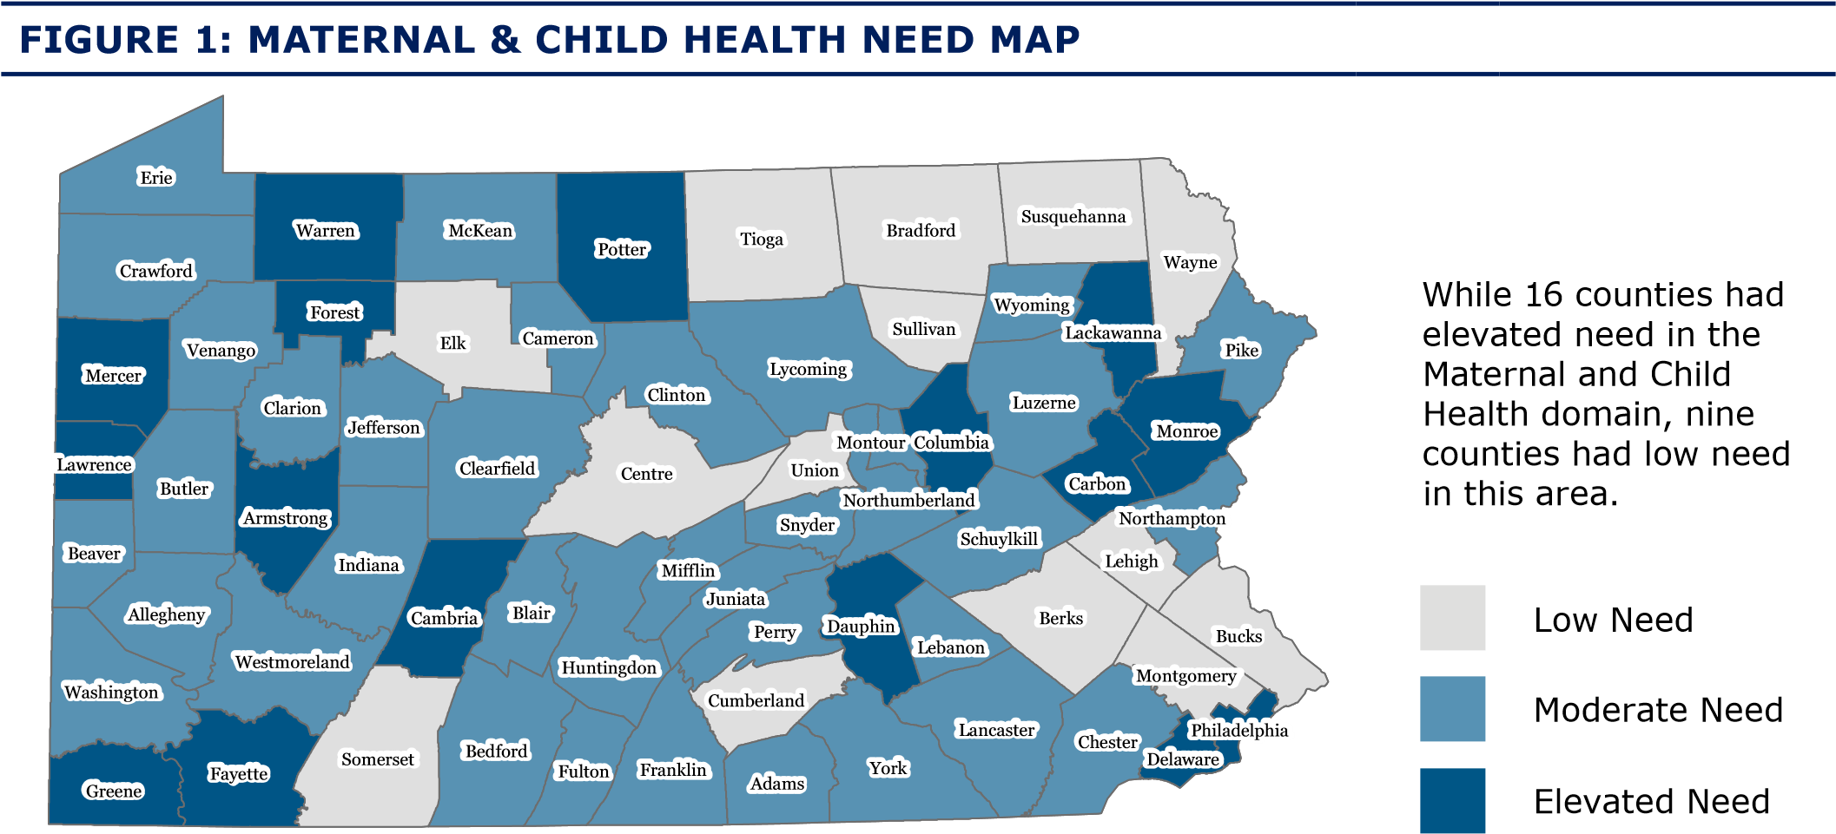
2020 Domain 2: Substance Use
In alignment with the requirement of the 2020 Needs Assessments to describe each state’s capacity to meet substance use treatment needs, this report compiles numerous indicators from various sources to describe the landscape of substance use services and treatment need across the state’s 67 counties.

Women and families struggling with substance use disorders need additional support throughout pregnancy and parenting. Early therapeutic intervention can lead to lifelong benefits for individuals with addiction disease and their families. Access to quality health care plays a vital role in long-term health outcomes for caregivers and children. It is estimated that 2 out of every 100 births are to individuals experiencing opioid use disorder in the year prior to delivery (Schiff et al., 2018). Among mothers enrolled in home visiting programs, 1 in 3 reported binge alcohol or illegal drug use prior to pregnancy, and 1 in 10 reported seeking professional treatment (Duggan et al., 2018). Individuals coping with the disease of addiction during pregnancy are at increased risk for inadequate prenatal care, infectious disease, obstetric complications, overdose and death. Additionally, caregivers with substance use disorders and their families face social challenges including the potential loss of child custody, mother-child separation due to incarceration, homelessness, exposure to violence, limited parenting opportunities and abilities, and trauma related mental health conditions. These challenges disproportionally affect caregivers of color, often resulting in underutilization of substance use treatment services for Black, Hispanic and other non-White caregivers (Acevedo et al., 2018). In Pennsylvania, the substance use epidemic has impacted both rural and urban communities, and has predominantly impacted adults of childbearing age. For caregivers in treatment and recovery, home visiting can serve as an additional layer of support. Substance use was identified by home visiting program administrators (see page 46 for more details) as a significant need within the client population and one that home visiting programs were reliant on community referrals to manage.

In 2018, Pennsylvania made available dollars for evidence-based home visiting agencies to pilot services dedicated toward this specialized population. Twenty state-funded pilot sites implemented varied strategies to serve families impacted by substance use in a diversity of geographic settings. These pilots offered an opportunity to understand the local level variability of implementation strategies for service coordination and to identify best practices for achieving enrollment, referral and service delivery goals for this population. An executive summary of early evaluation of this work can be found in Appendix 8. See Appendix 1 for indicators by county.

In 2016, Governor Wolf and PA DHS designated 45 Centers of Excellence for Opioid Use Disorder to provide wraparound mental and physical health support for families through community-based care management. These include primary care centers, Federally Qualified Health Centers (FQHCs), treatment providers, and single county authorities across 29 of Pennsylvania’s 67 counties. In January 2021, Pennsylvania will expand the Centers of Excellence for Opioid Use Disorder initiative to include additional substance use and mental health treatment providers operating on a fee-for-service model.

In alignment with the Families First Act, OCDEL and the Office of Children Youth and Families (OCYF) are jointly engaged in a number of efforts regarding connecting at-risk families to appropriate home visiting and substance support services. For instance, OCDEL is supporting OCYF as they choose the HV programs on the federal clearinghouse and will support OCYF build capacity for their high risk families.

In addition, OCDEL, OCYF, and Office of Medical Assistance Programs (OMAP) are working collaboratively to expand home visiting services to all families with a newborn or families considered to be high risk in subsequent pregnancies through physical Managed Care Organizations (MCO’s). This language is included in the MCO contracts. MCO’s and OCYF have been meeting with OCDEL’s home visiting programs to learn more about the models and consider potential contracts. As of January 2020, the MCO covered additional home visits were expanded and there are hopes to continue program expansion as capacity is built.

Staff at OCDEL and OCYF are on the planning committee for the design of the Resource and Referral tool for social determinants of health. This process has been under way since 2019 with the hopes of piloting this tool in nine counties beginning in 2021.

Starting in 2019, OCDEL partnered with OCYF in the Plans of Safe Care. These plans are a means to ensure all babies born substance exposed and their families have a plan that provides a safety net to families to ensure they have what they need to be successful at home. These efforts have prompted collaboration among numerous service providers – e.g., drug and alcohol counseling, home visiting services, Early Intervention, mental health services, etc – to create a comprehensive network within each county.

OCDEL continues to have a seat on the review board of OCYF’s Fatality and Near Fatality group. This group meets quarterly.

Additionally, in 2019, the Office of Child Development and Early Learning in the Pennsylvania departments of Education and Human Services oversaw the implementation of 20 home visiting pilot programs aimed at engaging and supporting pregnant and parenting families impacted by substance use and opioid use disorders. These pilots implemented various innovative strategies to recruit and serve families across all stages of the treatment and recovery continuum. Pilots were funded across a diversity of geographic settings and home visiting models, and featured a range of community partners including substance use treatment facilities, child welfare services, prisons, hospitals and recovery programs. An implementation evaluation of this work observed many successes in the planning and execution of these pilot programs.

A growing number of substance use treatment providers are addressing the unique needs of pregnant and parenting women. Substance use treatment, mental health treatment, and medication-assisted treatment providers are described in Table 4 of the report. There are a number of treatment facilities and providers that specifically serve pregnant and parenting women. For example, Sojourner House in Allegheny County provides residential recovery services for mothers and their aware County provides coordinated prenatal care and rehabilitative services for pregnant women; theealthhy MOMS program in Lackawanna and Susquehanna Counties (profiled in this report) provides prenatal and postpartum recovery care, counseling, and medication-assisted treatment for mothers with their newborns; Libertae in Bucks County provides long-term residential substance use treatment for mothers and children and on-site childcare; Community Services for Children SafeStart Program in Lehigh County provides wraparound therapeutic and treatment services for mothers and their substance-exposed newborns; Interim House West in Philadelphia County provides residential substance use treatment programs for women and their children.

Despite the presence of some highly specialized and innovative care models within treatment programs for women and families, more than half of Pennsylvania counties have no Centers of Excellence or residential programs that accommodate pregnant women and mothers with children. These targeted services are concentrated mostly in urban and suburban counties, highlighting the need for more service providers in rural counties where a lack of public transportation and long driving distances create barriers to accessing services outside of the county.

Our community survey highlighted perceived needs across the Commonwealth. Across all regions, respondents noted a shortage of substance use treatment centers. Overall, 60% of respondents reported the availability of substance use treatment services as “below average” or “not available” in their county, while only 13% felt that substance use treatment services were “very available.” The northern part of the Commonwealth, including the northwest, north central, and northeastern regions consistently reported less availability of services including substance use treatment centers.

TABLE 3: SUBSTANCE USE INDICATORS
Indicator | Definition | Year | Data Source | Min. | Med. | Max. | U.S. Rates
Postpartum high-risk opioid use | Prevalence of mothers receiving two or more opioid prescriptions in the postpartum year among Medicaid-enrolled mothers | 2017 | PA Birth  Certificate Data,  PA Medicaid Data | 2.5 | 9.2 | 20.5 | N/A
Substance treatment  facilities | Number of drug and alcohol treatment facilities per 100,000 residents | 2018 | Substance Abuse and Mental Health Services  Administration | 0.0 | 3.3 | 21.8 | 4.5
Mental health  treatment  facilities | Number of mental health treatment facilities per 100,000 residents | 2018 | Substance Abuse and Mental Health Services  Administration | 0.0 | 3.7 | 17.7 | 3.6
Buprenorphine physicians | Number of Buprenorphine treatment practitioner per 100,000 residents | 2018 | Substance Abuse and Mental Health Services  Administration | 0.0 | 5.4 | 38.5 | 26.6
Impaired drivers | Number of vehicle crashes involving impaired drivers per 100,000 residents | 2017 | PennDOT | 41.9 | 107.4 | 164.2 | N/A
Overdose deaths | Rate of overdose deaths per 100,000 people aged 15-64 years | 2017 | OverdoseFreePA | 0.0 | 29.0 | 77.0 | 11.3
Opioid overdose hospitalizations | Rate of hospitalization for opioid overdose per 100,000 residents | 20162017 | PA Health Care  Cost Containment  Council (PHC4) | 23.4 | 52.4 | 102.1 | 28.0
Neonatal abstinence syndrome | Rate of neonatal abstinence syndrome per 1,000 newborn hospital stays | 20162017 | PA Health Care  Cost Containment  Council (PHC4) | 3.2 | 15.7 | 76.0 | 7.0
Pregnancy and postpartum substance use disorder | Rate of substance use disorder among Medicaid-enrolled mothers who were pregnant or delivered live births in the past three years | 2016 | PA Birth  Certificates Data,  PA Medicaid Data | 2.4 | 5.4 | 15.0 | 2.3*
Alcohol use disorder | Prevalence rate of alcohol use disorder among individuals ages 12 and older | 2014- 2016 | SAMHSA – National  Survey of Drug  Use and Health | 4.8 | 5.8 | 7.1 | 5.6
Marijuana use | Prevalence rate of marijuana use in past month among individuals ages 12 and older | 2014- 2016 | SAMHSA – National  Survey of Drug  Use and Health | 5.5 | 7.0 | 13.9 | 8.9
Cocaine use | Prevalence rate of cocaine use in the past year among individuals ages 12 and older | 2014- 2016 | SAMHSA –  National Survey of Drug Use and Health | 1.1 | 1.3 | 3.3 | 0.7
Heroin use | Prevalence rate of heroin use in the past year among individuals ages 12 and older | 2014- 2016 | SAMHSA – National  Survey of Drug  Use and Health | 0.4 | 0.6 | 0.9 | 0.2
Maternal smoking during pregnancy | Rate of births to mothers who used tobacco during pregnancy per 100 live births | 2015 | PA Department of Health | 4.3 | 16.3 | 41.5 | 1.4
*SAMHSA, National Survey on Drug Use and Health, 2016, Pregnant women with alcohol or illicit drug abuse in the past year.

2020 Substance Use Need
Level of need within this domain was determined by weighting individual counties’ need level for each indicator. Three counties were at elevated need for 8 of the 14 indicators and three counties had no elevated need in any indicator in this domain. Prenatal and postpartum substance use, important indicators of maternal and infant health and well-being, varied widely across counties. Prenatal tobacco use and high-risk postpartum opioid were most elevated in the northwestern and north central regions of the state.

Two counties had zero annual overdose deaths per 100,000 adult residents while others saw as many as 77 deaths per 100,000 adult residents.

TREATMENT ACCESS & CAPACITY:
- Over half of the 67 counties had low levels of access to Buprenorphine, substance use treatment or mental health treatment providers. Low access was not concentrated to one particular region. However, notably, in the northeast, one county was observed with zero Buprenorphine, substance use treatment or mental health providers per 100,000 residents.
- In general, there was a higher capacity to treat substance use in counties exhibiting the highest rates of neonatal abstinence syndrome, postpartum high-risk opioid use and overdose deaths.
Low Need | Moderate Need |  | Elevated Need
Berks | Adams | Indiana | Armstrong
Blair | Allegheny | Lackawanna | Cambria
Chester | Beaver | Luzerne | Clinton
Cumberland | Bedford | Lycoming | Fayette
Dauphin | Bradford | McKean | Greene
Delaware | Bucks | Mercer | Lawrence
Franklin | Butler | Mifflin | Northumberland
Fulton | Cameron | Montour | Perry
Jefferson | Carbon | Northampton | Philadelphia
Juniata | Centre | Pike | Potter
Lancaster | Clarion | Schuylkill | Snyder
Lebanon | Clearfield | Somerset | Sullivan
Lehigh | Columbia | Tioga | Susquehanna
Monroe | Crawford | Union | Venango
Montgomery | Elk | Warren | Westmoreland
Wyoming | Erie | Washington
York | Forest | Wayne
 | Huntingdon
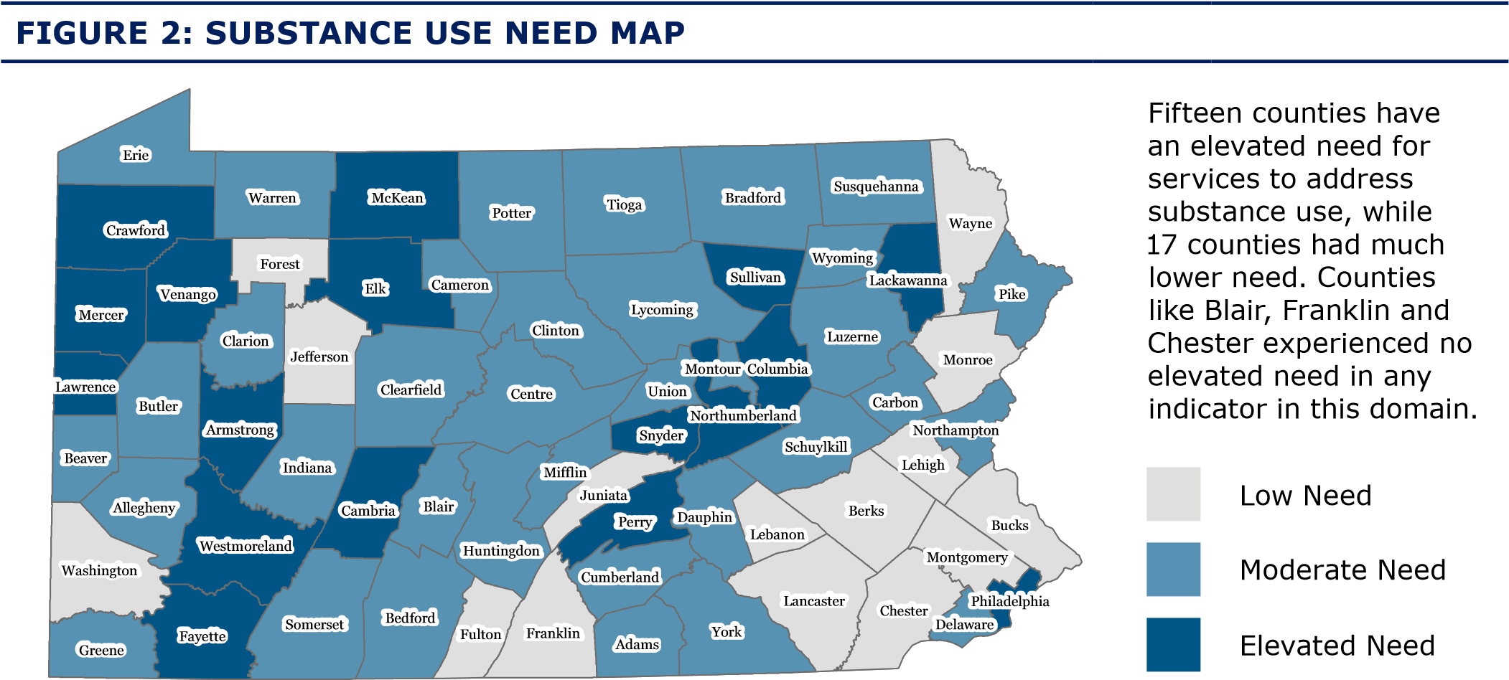

2020 Domain 3: Socioeconomic Status
The economic and social contexts of children affect their health and well-being throughout the course of their lives (Lu & Halfon, 2003). Both individual and community economic factors influence stress levels in mothers and children, which can lead to adverse health outcomes. Home visiting programs primarily serve families in under-resourced communities because interrupting the cycle of poverty and its impact on the health and well-being of families of young children is critically important to addressing health inequities (MOD-a, 2017; MOD-b, 2017; MOD-c, 2018; MOD-d, 2018). Poverty and low socioeconomic status disproportionately effect Black and Hispanic families and children. In Pennsylvania, about one-third of Black and Hispanic children live in poverty, three times the rate of White children (Census, 2018). See Appendix 1 for indicators by county.

TABLE 5: SOCIOECONOMIC STATUS INDICATORS
Indicator | Definition | Year | Data Source | Min. | Med. | Max. | U.S. Rates
Poverty | Percent of population living below 100% of the Federal Poverty Level (FPL) | 20142018 | Census | 6.1 | 12.7 | 24.9 | 15.1
Child poverty | Percent of children under age 5 living in poverty | 20142018 | Census | 7.5 | 21.2 | 34.3 | 18.4
Income inequality | Gini Coefficient measurement of income inequality scaled 0  to 1 | 20142018 | American  Community Survey | 0.4 | 0.4 | 0.5 | 0.4
Unemployment | Unemployed percent of civilian labor force | 2019 | Bureau of Labor Statistics | 3.2 | 4.7 | 6.8 | 3.7
Teens not in school | Percent of 16-19 year olds not enrolled in school and with no high school diploma | 2017 | American  Community Survey | 0.5 | 4.3 | 19.0 | 4.0
Teen births | Number of births per 1,000 females ages 15-19 | 20112017 | National Center for Health Statistics | 4.0 | 22.0 | 37.0 | 24.2
Mothers without high school diploma | Percent of births to mothers whose educational attainment is below high school | 2017 | PA Department of Health | 3.9 | 13.3 | 34.7 | 13.0
Public assistance | Percent of households with children under 18 who have received SSI, cash assistance or SNAP | 20132017 | American  Community Survey | 10.2 | 25.6 | 51.3 | 24.4
Renters who are cost-burdened | Percent of renters whose rent  is 30% or greater of total  income | 20132017 | Census, Federal Reserve Bank | 23.5 | 39.9 | 57.7 | 35.6
WIC redemptions | Per capita dollar amount of WIC redemptions | 2017 | USDA | 5.6 | 14.4 | 37.1 | 41.3
Child food insecurity | Percent of children who live in food-insecure households | 2017 | USDA | 12.1 | 17.9 | 24.4 | 17.0

2020 Socioeconomic Need
Level of need within this domain was determined by weighting individual counties’ need level for each indicator. One county had elevated need for 9 of the 11 indicators and eight counties had no indicators with elevated need in this domain.

The rates of unemployment and teen births were similar across counties. While Pennsylvania’s statewide rate of families with children receiving public assistance was similar to the national rate, these benefits were concentrated in a few counties where roughly half of families were receiving SSI, cash assistance or SNAP benefits.

In 20 counties, at least 1 in 4 children under age 5 live in poverty. The highest rates of child poverty were concentrated in the northwest and north central regions. At least one-quarter of renters are considered cost-burdened in every county, some with rates higher than 50%. The highest rates were in the northeast and southeast regions.

Low Need | Moderate Need |  | Elevated Need
Adams | Allegheny | Lancaster | Cambria
Armstrong | Berks | Lawrence | Cameron
Beaver | Blair | Lebanon | Clearfield
Bedford | Bradford | Lehigh | Clinton
Butler | Bucks | Lycoming | Erie
Cumberland | Carbon | Monroe | Fayette
Elk | Centre | Montgomery | Forest
Northampton | Chester | Montour | Greene
Susquehanna | Clarion | Northumberland | Jefferson
Wayne | Columbia | Perry | Luzerne
Westmoreland | Crawford | Pike | McKean
Wyoming | Dauphin | Schuylkill | Mercer
York | Delaware | Snyder | Mifflin
 | Franklin | Somerset | Philadelphia
 | Fulton | Sullivan | Potter
 | Huntingdon | Tioga
 | Indiana | Union
 | Juniata | Venango
 | Lackawanna | Warren
 |  | Washington
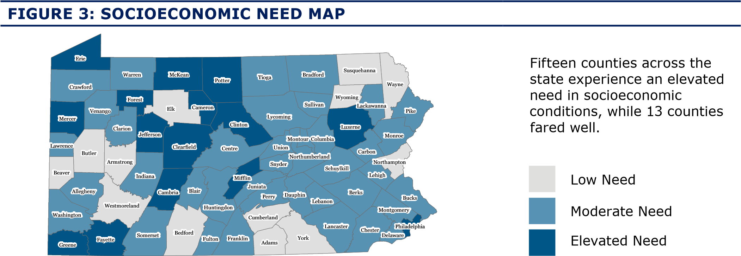

2020 Domain 4: Child Safety & Maltreatment
Child maltreatment is a serious public health issue. Children exposed to abuse or neglect may experience acute and long-term adverse health outcomes including injury, death, chronic disease morbidity and social-emotional impairments (CDC, 2019). Access to supports that address caregiver mental health, substance use and housing, as well as preventive programs that teach positive parenting skills, can improve the safety and well-being of children and their families. This domain includes indicators compiled from multiple systems serving families to inform a comprehensive picture of child safety and maltreatment need. See Appendix 1 for indicators by county.

TABLE 7: CHILD SAFETY & MALTREATMENT INDICATORS
Indicator | Definition | Year | Data Source | Min. | Med. | Max. | U.S. Rates
Child maltreatment | Number of substantiated child maltreatment victims under 18 years old | 2019 | PA Department of Human Services, OCYF | 0.000 | 2.200 | 6.700 | 9.120
Substantiated young child abuse and neglect | Number of substantiated child abuse and neglect victims per 1,000 children ages 0-4 | 2016 | PA Department of Human Services, OCYF | 0.000 | 2.268 | 8.252 | 13.596
Abuse against pregnant and  postpartum women | Rate of diagnosed abuse among Medicaid-enrolled pregnant women or women who gave birth in the past 3 years | 2016 | PA Birth Certificate and Medicaid  Claims | 0.000 | 0.003 | 0.010 | 0.002
Domestic violence-related deaths of women | Number of domestic violence related deaths per 1,000 females ages 15-50 years | 20052019 | PA Coalition  Against Domestic  Violence | 0.000 | 0.221 | 1.502 | 0.01**
Protection from abuse order | Number of judge-grated protection from abuse orders per 1,000 residents | 2018 | PA Courts | 0.000 | 0.453 | 2.965 | N/A
Infant nonsuperficial injury | Number of children with nonsuperficial injuries during the first year of life per 1,000  Medicaid-enrolled children | 20082014 | PA Birth Certificate and Medicaid Claims | 0.007 | 0.013 | 0.020 | N/A
Young child nonsuperficial injury | Number of children with nonsuperficial injuries during the first 5 years of life per 1,000 Medicaid-enrolled children | 20082014 | PA Birth Certificate and Medicaid Claims | 0.051 | 0.073 | 0.111 | N/A
Child welfare inhome services | Percent of children under age  18 receiving child welfare inhome services in FY 2017-2018 | 20172018 | PA Department of Human Services, OCYF | 1.267 | 10.233 | 50.825 | 1.821
Substance use need | Composite score of selected substance use indicators | 20142017 | See Substance Use Domain | 0.000 | 0.211 | 0.667 | N/A
**Intimate partner violence-related deaths of women 15-50 for the years 2005-2017, CDC NVDRS data

2020 Child Safety & Maltreatment Need
Level of need within this domain was determined by weighting individual counties’ need level for each indicator. One county had elevated need for 9 of the 10 indicators and nine counties did not have elevated need for any indicator in this domain.

In all counties, child maltreatment rates were lower than the national rate of 9 victims per
1,000 children. Two counties with the lowest rates of substantiated infant and young child abuse and neglect had the highest rates of child welfare in-home prevention services. Elevated rates of health care encounters for non-superficial injuries were present in 10 counties where substantiated reports of maltreatment were not observed as elevated, indicating a potential unmet need for prevention services.

Three counties were observed to have 1 or more women per every 1,000 female residents between the ages of 15 and 50 killed by a domestic or intimate partner.

Low Need | Moderate Need |  | Elevated Need
Beaver | Adams | Lackawanna | Bradford
Berks | Allegheny | Lawrence | Carbon
Bucks | Armstrong | Lehigh | Clearfield
Butler | Bedford | Luzerne | Columbia
Centre | Blair | Mifflin | Crawford
Chester | Cambria | Monroe | Elk
Cumberland | Cameron | Montour | Fayette
Delaware | Clarion | Pike | Forest
Franklin | Clinton | Snyder | Greene
Indiana | Dauphin | Sullivan | Lycoming
Juniata | Erie | Susquehanna | McKean
Lancaster | Fulton | Union | Mercer
Lebanon | Huntingdon | Wayne | Northumberland
Montgomery | Jefferson | Westmoreland | Philadelphia
Northampton |  | Wyoming | Potter
Perry |  |  | Tioga
Schuylkill |  |  | Venango
Somerset
Warren
Washington
York
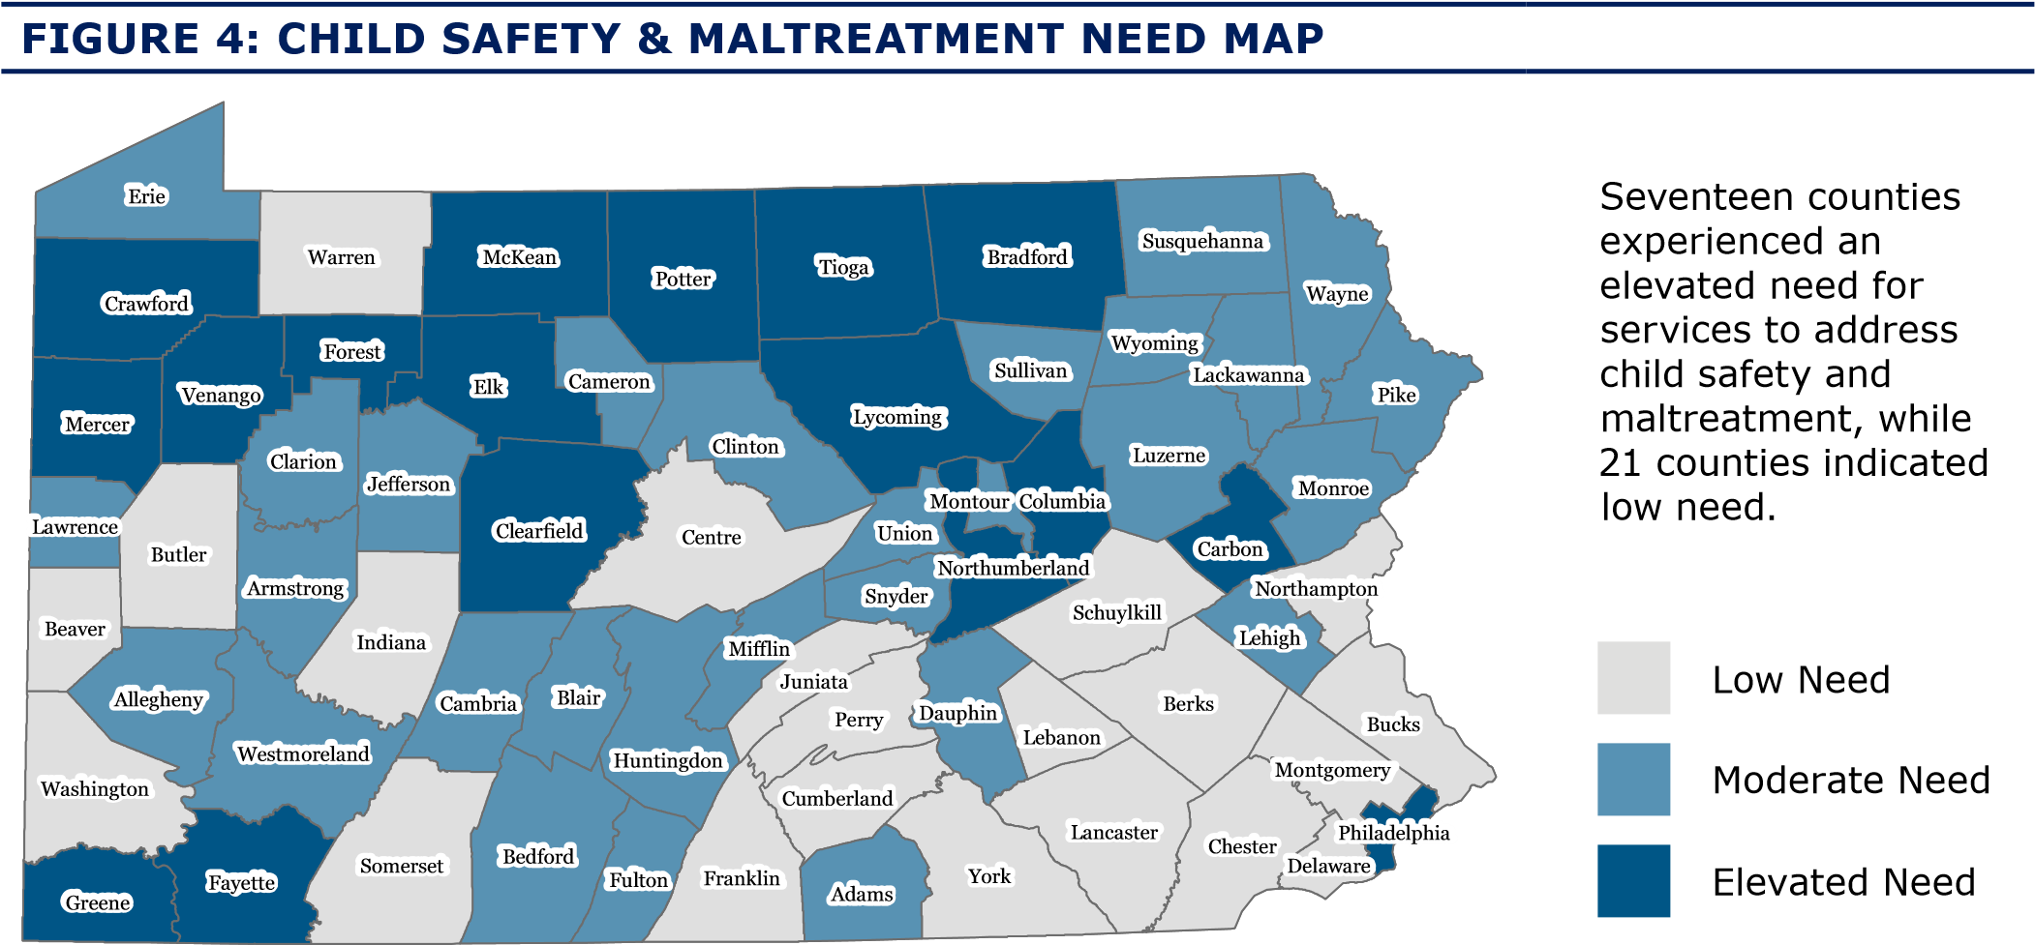

2020 Domain 5: Community Environment
A family’s community environment is where they live, work and play. Community has a strong influence on family well-being. Families must have access to necessary goods and services such as food and health care, clean air to breathe and safe community spaces. Community environments can be socially and physically protective to health, or, conversely can contribute to poor health and increased stress. Historic and systemic racism, exemplified by residential segregation and disproportionate environmental exposures, harm the health and well-being of Black, Indigenous and people of color. For example, in Pennsylvania, non-Hispanic Black and Hispanic children experience lead poisoning at higher rates than non-Hispanic White children (CDC, 2018). See Appendix 1 for indicators by county.

TABLE 9: COMMUNITY ENVIRONMENT INDICATORS
Indicator | Definition | Year | Data Source | Min. | Med. | Max. | U.S. Rates
SNAP-authorized stores | Number of SNAPauthorized stores per 1,000 families | 2012 | USDA | 2.7 | 7.2 | 15.8 | 0.8
WIC-authorized stores | Number of WIC-authorized stores per 1,000 families with children under age 6 | 2012 | USDA | 1.4 | 3.3 | 47.6 | 3.1
Low income and low access census tracts | Percent of census tracts with low income and low access to grocery stores | 2015 | USDA | 0.0 | 7.4 | 50.0 | 12.7
Hospitals | Number of hospital beds per 1,000 residents | 2016 | HRSA | 0.0 | 2.6 | 42.5 | 2.4
Community Health Centers | Number of Federally Qualified Community Health Centers (FQHCs) and related organizations per 100,000 residents | 2018 | HRSA | 0.0 | 1.4 | 44.5 | 4.4
Primary care physicians | Number of primary care physicians per 1,000 residents | 2016 | HRSA | 0.0 | 0.6 | 4.5 | 1.6
Pediatric dentists | Number of active pediatric dentists per 1,000 children under age 18 | 2017 | PA Coalition for Oral Health | 0.0 | 0.0 | 0.3 | 0.1
Crimes | Number of reported crimes per 1,000 residents | 2016 | US DOJ | 7.9 | 15.6 | 41.5 | 18.8
Juvenile arrests | Number of crime arrests per 100,000 juveniles ages 0-17 | 2016 | US DOJ | 683.0 | 1554.8 | 5570.3 | 1162.4
Environmental quality | Average index score of potential exposure to harmful toxins | 2015 | US HUD | 20 | 83 | 97 | 49.5

Libraries | Number of libraries per 100,000 residents | 2015 | Institute  of Museum and Library Services | 2.2 | 5.5 | 29.5 | 2.9
Car ownership in rural counties | Percent of census tracts with low care ownership (Indicator used in 61 rural counties) | 2017 | US Census Bureau | 14.3 | 50.0 | 100.0 | N/A
Public transit in urban counties | Public transit performance score (Indicator used in 6 urban counties) | 2016 | Center for  Neighborhood  Technology | 2.4 | 4.9 | 9.0 | N/A
Children blood lead level | Percent of children with  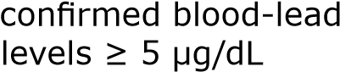 | 2017 | CDC | 1.0 | 5.9 | 28.9 | 3.0
Residential segregation | Index of dissimilarity where higher values indicate greater residential segregation between Black and White county residents | 20142018 | Census | 34 | 57 | 76 | N/A

2020 Community Environment Need
Level of need within this domain was determined by weighting individual counties’ need level for each indicator. Two counties had elevated need for 8 of the 14 indicators and two counties had no elevated need in this domain.

Statewide, 5% of children had elevated blood lead levels and in nine counties, at least 1 in 10 children experienced lead poisoning.

The southeastern region and mostly urban counties had the highest exposure to environmental hazards.

Half of rural counties had areas with low levels of car ownership. Many of these were in the northwest and north central regions of the state. Five rural counties with low levels of car ownership were also low income and low access as defined by the United States Department of Agriculture (USDA), meaning that 30% of residents live over 10 miles from a food store.

At the same time, many rural counties in the northern part of the state had access to a high number of libraries per resident.

Low Need | Moderate Need |  | Elevated Need
Adams | Allegheny | Lehigh | Armstrong
Berks | Bedford | Lycoming | Beaver
Bradford | Butler | Mifflin | Blair
Centre | Cambria | Montgomery | Bucks
Clarion | Chester | Northampton | Cameron
Columbia | Clinton | Northumberland | Carbon
Elk | Crawford | Perry | Clearfield
Franklin | Cumberland | Pike | Fayette
Fulton | Dauphin | Potter | Forest
Greene | Delaware | Schuylkill | Huntingdon
Lancaster | Erie | Snyder | Juniata
Luzerne | Indiana | Somerset | McKean
Montour | Jefferson | Susquehanna | Mercer
Washington | Lackawanna | Tioga | Monroe
Wayne | Lawrence | Union | Philadelphia
Westmoreland | Lebanon | Venango | Sullivan
Wyoming |  | Warren | York
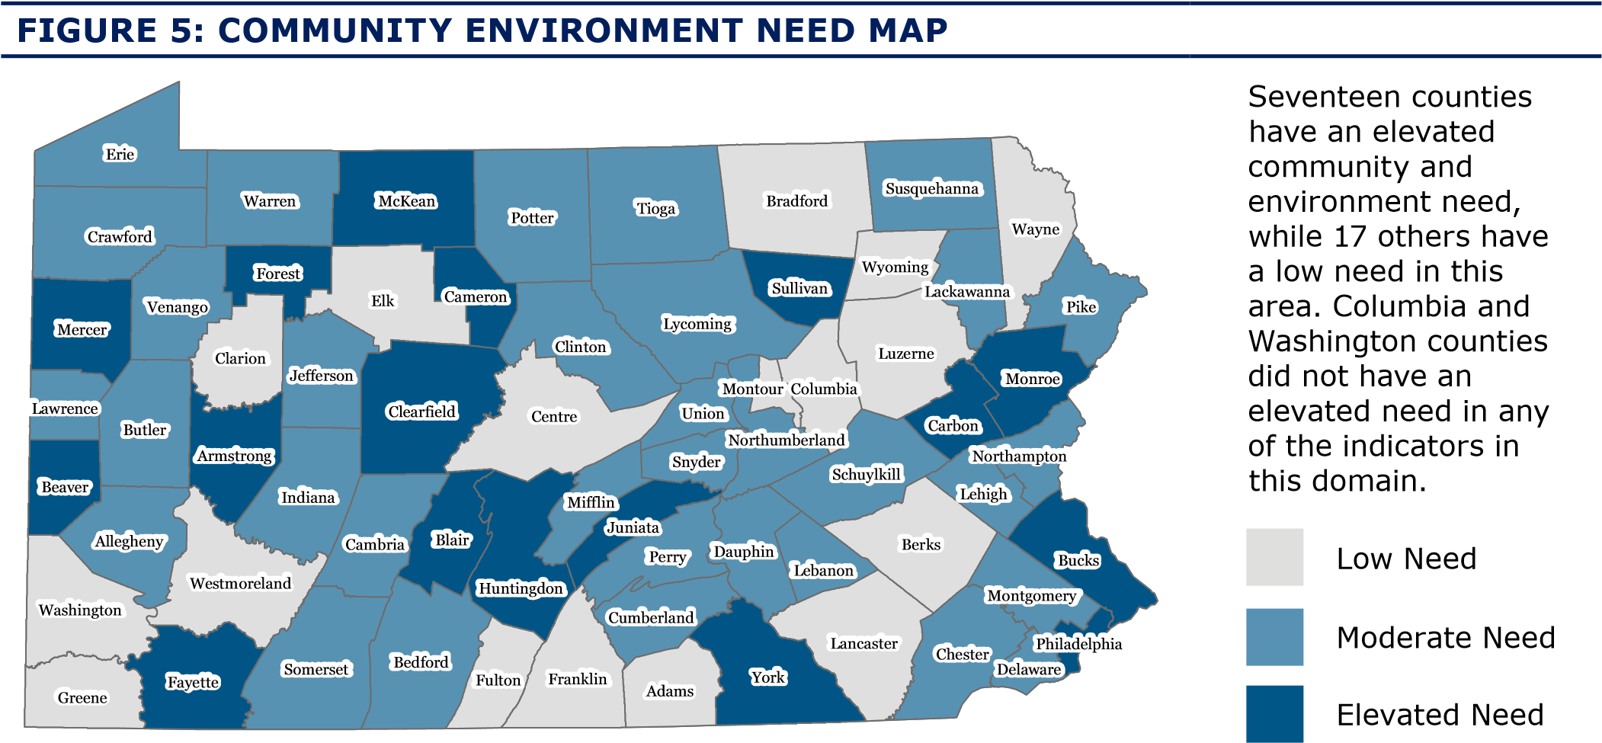

2020 Domain 6: Child Care
Safe and quality child care is necessary to support the healthy social and emotional development of children. Rural communities face unique experiences and challenges to building and maintaining access to high-quality child care and publicly funded pre-K, and rely more heavily on home- and family-based care. Child care subsidies reduce disparities in access to quality child care.

Keystone STARS is Pennsylvania’s quality rating system for early learning and child care in the state. Supported by OCDEL, and administered through locally implemented Early Learning Resource Centers (ELRC), Keystone STARS measures qualifications, classroom environment, curriculum, family engagement and business management. Learn more about Pennsylvania’s quality rating system here. See Appendix 1 for indicators by county.

TABLE 11: CHILD CARE INDICATORS
Indicator | Definition | Year | Data Source | Min. | Med. | Max. | U.S. Rates
Regulated child care | Number of regulated child care providers per 100 children residents under age 3 | 2018-  2019 | PA OCDEL | 0.0 | 1.1 | 2.3 | N/A
High-quality child care | Percent of regulated child care providers meeting high-quality standards (STAR 3 & 4) | 2018-  2019 | PA OCDEL | 0.0 | 25.0 | 68.3 | N/A
Subsidized child care | Percent of children ages 0-5 eligible for Child Care Works (CCW) who were served by CCW | 2018-  2019 | PA OCDEL | 0.0 | 22.6 | 66.2 | N/A
Publicly funded pre-K | Percent of children ages 3-4 below 300% FPL with access to publicly funded, high quality pre-k | 2018-  2019 | PA OCDEL | 14.2 | 40.5 | 77.2 | N/A
Quality of subsidized child care | Percent of children ages 0-5 receiving subsidized child care in Keystone STARS 3 or 4 facilities | 2018-  2019 | PA OCDEL | 0.0 | 42.0 | 81.8 | N/A
PA Pre-K Counts (PKC)** | Number of children served by PKC | 2018-  2019 | PA OCDEL | 15 | 203 | 4791 | 1,565,239*
Head Start  Supplemental  Assistance Program  (HSSAP)** | Number of children served by HSSAP | 2018-  2019 | PA OCDEL | 0 | 50 | 2315 | 676,178

*Pre-K participation as defined by the U.S. Department of Human Services, Administration for Children and Families **PKC and HSSAP are not included in the calculation of domain composite need score.
2020 Child Care Need
Level of need within this domain was determined by weighting individual county’s need level for each indicator. Four counties had elevated need for four of the five indicators and two counties had no elevated need in this domain.

Over half of the counties in the state had at least one regulated child care provider per 100 children under age 3. Four counties had zero child care facilities that have yet received Keystone STARS 3 or 4 designations. In contrast, half to two-thirds of providers in other counties met this designation. Pennsylvania rural communities had fewer quality child care slots per child available compared to their urban counterparts.

In 30 counties, at least 1 out of 4 children ages 0-5 who are eligible for subsidized child care were served by subsidized child care. The highest rates were in more urban counties in the southeast region. The lowest rates were in rural counties in the south and north central regions. In almost half of counties, the majority of children receiving subsidized childcare were in Keystone STARS 3 or 4 facilities.

Low Need | Moderate Need |  | Elevated Need
Allegheny | Adams | Indiana | Bedford
Blair | Armstrong | Jefferson | Carbon
Bradford | Beaver | Lackawanna | Clinton
Butler | Berks | Lancaster | Forest
Cameron | Bucks | Lawrence | Franklin
Centre | Cambria | Mifflin | Juniata
Columbia | Chester | Northampton | Lehigh
Crawford | Clarion | Philadelphia | Monroe
Delaware | Clearfield | Pike | Northumberland
Erie | Cumberland | Schuylkill | Perry
Lebanon | Dauphin | Somerset | Potter
Luzerne | Elk | Susquehanna | Snyder
Lycoming | Fayette | Union | Sullivan
McKean | Fulton | Warren
Mercer | Greene | Washington
Montgomery | Huntingdon | Wyoming
Montour |  | York
Tioga
Venango
Wayne
Westmoreland
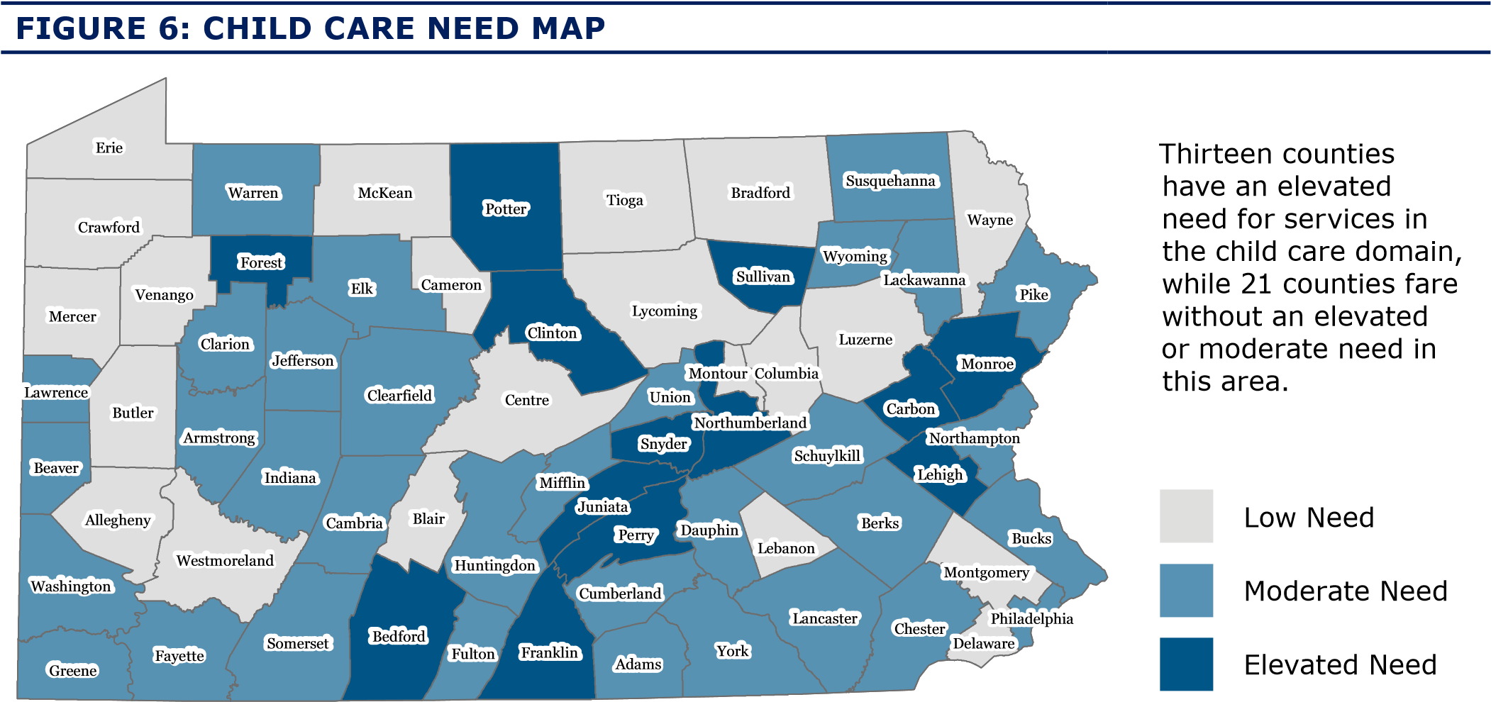
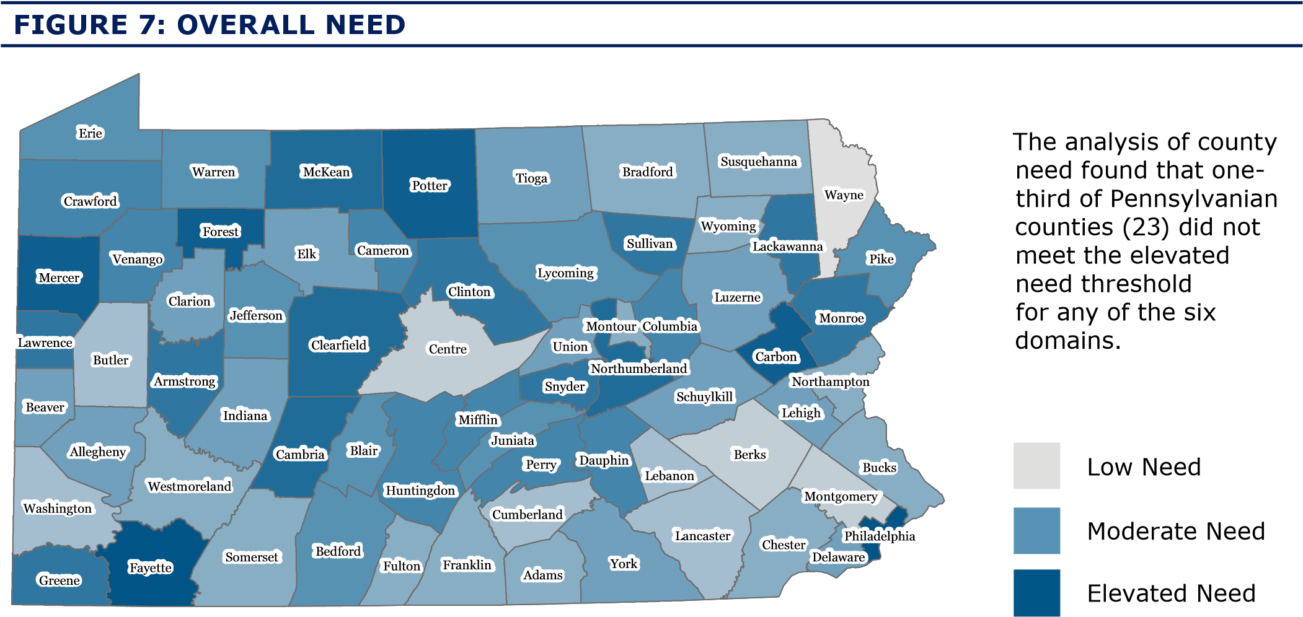

In addition to mapping each domain, the overall need score summarizing all domains was mapped statewide (shown in Figure 7). Creation of the overall need score is described in detail (pg. 9), and shows a wider range of need, from lower to elevated need across the state. Of the 45 counties reaching elevated need status in at least one domain, 15 met elevated need thresholds in three or more domains. Of these 15 counties with high concentrations of need, 10 were distributed across the northern region (4 northwest, 3 north central and 3 northeast) and 5 were in the southern region (4 southwest, 1 southeast).

2020 Quality and Capacity of Existing Services
Since its inception in 2007, the Office of Child Development and Early Learning (OCDEL)
has focused on creating opportunities for Pennsylvania’s youngest children to develop and learn to their fullest potential. They accomplish this through a framework of supports and systems that provide at-risk children and their families with access to high-quality services to meet their complex needs. OCDEL continues to strive to build a strong foundation for children through engaging and strengthening families, promoting family leadership in local communities, the establishment of statewide standards of excellence in early care and education, and by providing financial and technical supports.

In order to robustly support Pennsylvanian families, OCDEL works with many partners. Parents, schools, child care, Early Intervention, Head Start/Early Head Start, child welfare, libraries, community organizations, and other stakeholders have joined with OCDEL to provide high-quality early childhood programs and effective prevention strategies to mitigate challenges faced by families that affect school readiness and life success. OCDEL also partners with other state agencies to ensure the myriad of services for children and families are aligned and well-coordinated.

The information collected to inform this assessment includes publicly funded (state and federal) slots administered through OCDEL and does not include other investments in home visiting or family support programs administered locally through philanthropic investment or by other local or state agencies. While information is not included in this assessment, OCDEL does partner with other state agencies on non-MIECHV- or non-OCDEL-funded home visiting and family support efforts that exist to ensure services are addressing the needs of communities.
In addition to federal dollars, the state has made significant state investments in a variety of evidence-based home visiting (EBHV) and other family support programs. The funds supporting program models administered by OCDEL are made possible by various funding mechanisms, including: MIECHV, Nurse-Family Partnership, Promoting Responsible Fatherhood and state funding for EBHV programs. In 2018, OCDEL absorbed the Family Center line item from the Department of Human Services Office of Children Youth and Families (OCYF) along with the existing contracted program slots to be served under those agreements.

2020 Summary of Capacity
Information was collected from Pennsylvania’s network of local implementing agencies (LIAs) as well as OCDEL’s grants management system to identify information about existing programs or initiatives for early childhood home visiting across the state. We obtained program enrollment information for state fiscal years (SFY) 2016-17 and 2019-20. The table in Appendix 6 provides a detailed account of the total number of families contracted to be served at the county level for SFY 2016-17 and the most recent fiscal year available (2019-20), as well as the information requested to meet the federal requirements of this assessment.

The term funded slots is used to describe the total number of families served, at any given time throughout a fiscal year, contracted between OCDEL and a LIA. HRSA provided estimated number of eligible families by county, defined as families with children under 6 years old that were living in poverty and met two of three additional risk factors (families in which the mother has low educational attainment (high school education or less); families with pregnant women (a child less than 1 year in the past year); or families with young mothers (aged under 21)). States were also offered the opportunity to estimate the eligible population using an alternate calculation. For purposes of this assessment, we used the U.S. Census American Community Survey 2014- 2018 five-year average to identify the number of families with children ages 0-5 living below 200% of the federal poverty level in each county. This number is consistent with figures used by evidence-based home visiting models and more accurately reflects the population served by home visiting across Pennsylvania given the breadth of models implemented.

Pennsylvania significantly increased its investment in evidence-based home visiting programs over the last four years. In SFY 2016-17, OCDEL administered funding to support a total of 5,235 families across 57 counties to implement four evidenced-based home visiting models: Early Head Start, Healthy Families America, Nurse-Family Partnership and Parents As Teachers. By SFY 2019-20, the state increased its investment in EBHV funded slots by 52%
and expanded availability of funds to include an additional two models: Family Check-up and SafeCare Augmented. In SFY 2019-20, 46 of the 67 counties received federal MIECHV dollars; through additional state funds, all 67 counties across the state offer at least one of the seven EBHV models.

An additional 2,710 slots were created between SFY 2016-17 and SFY 2019-20. Taking into consideration the 2,205 slots absorbed through the existing PA Department of Human Services OCYF Family Center Line item contracts in 2018, the state’s new total investment in EBHV in SFY 2019-20 was 10,150 funded slots. OCDEL also increased availability of services to an additional 10 counties bringing federal- and state-funded evidence-based home visiting to all of the state’s 67 counties. Using the alternate calculation to identify eligibility for services, the current state and federal investment in home visiting administered through OCDEL represents approximately 5% of the total number of families eligible for home visiting across all 67 counties.

For evidence-based home visiting models, the availability of financial resources to expand service availability within the eligible population is a barrier to meeting the service needs within counties. Roughly one quarter of community survey respondents indicated that pregnancy and parenting support services were below average availability in their community (23%).

There is wide variation in saturation of services among eligible families at the county level with penetration rates ranging from 0.1% in Carbon County to 18.4% in Greene County. Some of the observed variation is reflective of a prioritized investment in communities with elevated needs. When looking at the 15 counties with concentrations of need—where elevated need was observed across 3 or more of the 6 domains—the average saturation of state investment in home visiting services (5.9%) is higher than the aggregate statewide average (4.8%). Three counties in particular – Greene, Mercer and McKean – have double the investment of the statewide average.

In assessing the additional areas of service quality, the administrative and community survey data highlight barriers experienced at the local level. Specifically, no major gaps or barriers were identified by local program administrators with respect to staffing. If anything, data from the administrative survey highlighted many strengths, including the tenure of program staff with local implementing agencies and a workforce that reflects the racial, ethnic, and linguistic makeup of the community they serve. While there were no major barriers or gaps identified in staffing, challenges in accessing community resources to support families were highlighted. Specifically, we found that the four most pronounced issues facing families across urban and rural communities in the state include substance abuse, mental health, economic issues (e.g., unemployment) and intimate partner violence. These gaps in services were both signaled by the administrative data indicators and highlighted by community members and home visiting program administrators in survey data. Among home visiting clients surveyed (n=263), only 5 indicated that help with tobacco, substance, or domestic violence were among the top five most useful services provided by their home visiting programs.

In general, economic and resource assistance (e.g., job search, housing, benefits enrollment) were also less frequently endorsed as among the most useful home visiting services to clients, falling well below knowledge of child development and parenting skills related services. Improved access to community resources may improve the ability of home visiting to provide meaningful service connectivity while continuing to deliver quality parenting education.

2020 Summary of Administrative Survey Results
To assess additional areas of service quality and capacity, local home visiting administrators across the state completed a survey about their home visitor workforce, client needs, and agency responses to particular issues related to maternal, child and family health. (See Appendix 7 for the survey question used.)

Across the 55 survey respondents, there was great variation in the size of staff, ranging from 1 to 68 home visitors, with a median of 7 home visitors. (In the discussion that follows, we used the median number of home visitors to define large sites as those with more than 7 home visitors and small sites as those with 7 or fewer home visitors.) On average, urban sites had more home visitors than rural sites1 (14.2 compared to 8.4 staff respectively). The vast majority of sites indicated that over half of their home visiting staff are full-time employees, with 31 respondents reporting that all home visitors are full-time. The average proportion of full-time staff did not differ between urban and rural sites, 86% compared to 85%, respectively, and was slightly lower than the national average across models at 91% (Boller et al., 2014). Two smaller agencies from urban areas reported that all of their staff were employed part-time. Administrators were also asked to describe their staff’s level of experience by indicating how many staff had less than one year, one to three years or more than three years of experience in the field. Overall, staff tended to be more experienced, with an average of 63% of staff having more than three years of experience, 17% having one to three and 20% with less than one. Staff at rural sites tended to be more experienced than staff at urban sites—on average, a greater proportion of urban staff had less than 1 year experience (23.7% at urban sites vs. 16.9% at rural sites) and rural sites had a greater proportion of staff with more than 3 years of experience (69.9% at rural sites vs. 54.9% at urban sites).

In the survey, administrators answered a few questions that shed light on how closely the home visiting workforce reflects the identities of their clients. Twenty-seven of the 55 agencies had at least one multilingual home visitor on staff. Comparing urban and rural sites with at least one multilingual home visitor, urban sites had a greater proportion of multilingual staff on average (29% vs. 19% at rural sites). Home visitors from the remaining 28 agencies spoke only English, 20 of which were rural sites. When the 27 agencies with multilingual staff were asked what language(s) home visitors spoke, 25 agencies reported Spanish, 4 French and 2 German. Lastly, we asked administrators, “Does your workforce reflect the racial, ethnic or linguistic identities of your clients?” The majority of administrators responded yes. Rural sites were more likely to report yes, that their staff matched the racial, ethnic or linguistic identities of clients (18 rural sites compared to 10 urban sites), while urban sites more often answered somewhat (15 urban sites vs. 10 rural sites). The two sites that responded no to this question were smaller urban sites.

Finally, administrators were asked to identify the most frequent risk factors observed among their client population, each administrator was asked to prioritize 3 from a list of 16 items related to caregiver needs, caregiver populations, child welfare, special health care needs and substance abuse. Caregiver needs related to history of or current mental health diagnosis was the most frequently selected response (39 respondents), followed by caregiver needs related to unemployment (22 respondents) and having a history of substance abuse (19 respondents). These three most frequently selected items were endorsed equally by rural and urban sites. Rural sites more often cited current substance abuse, grandparents or other kin caregivers raising youth, and parents with developmental delays or other special health care needs. Urban sites were more likely to report domestic violence, non-English speaking and migrant families as frequent risk factors. Importantly, three urban sites selected “Other” to write in homelessness or housing insecurity as a top risk factor impacted their families.

Administrators were then asked to describe their agency’s response to common maternal, child and family needs—for instance, “dental health care for children” and “help for alcohol or drug use/abuse.” Response options were, “provide direct services,” “refer clients to these services,” “not applicable for our program model(s)” or “other.”

Responses demonstrated which services agencies were prepared to manage versus those for which they depend on outside support. The vast majority of respondents indicated that their agency directly provides information for fathers, grandparents and other kin serving as caregivers, and materials about how to keep children safe and prevent injuries. Conversely, help for domestic or sexual violence, assistance for alcohol or drug use/abuse, and mental health or behavioral health services for an adult or child were all issues for which many agencies referred clients elsewhere.
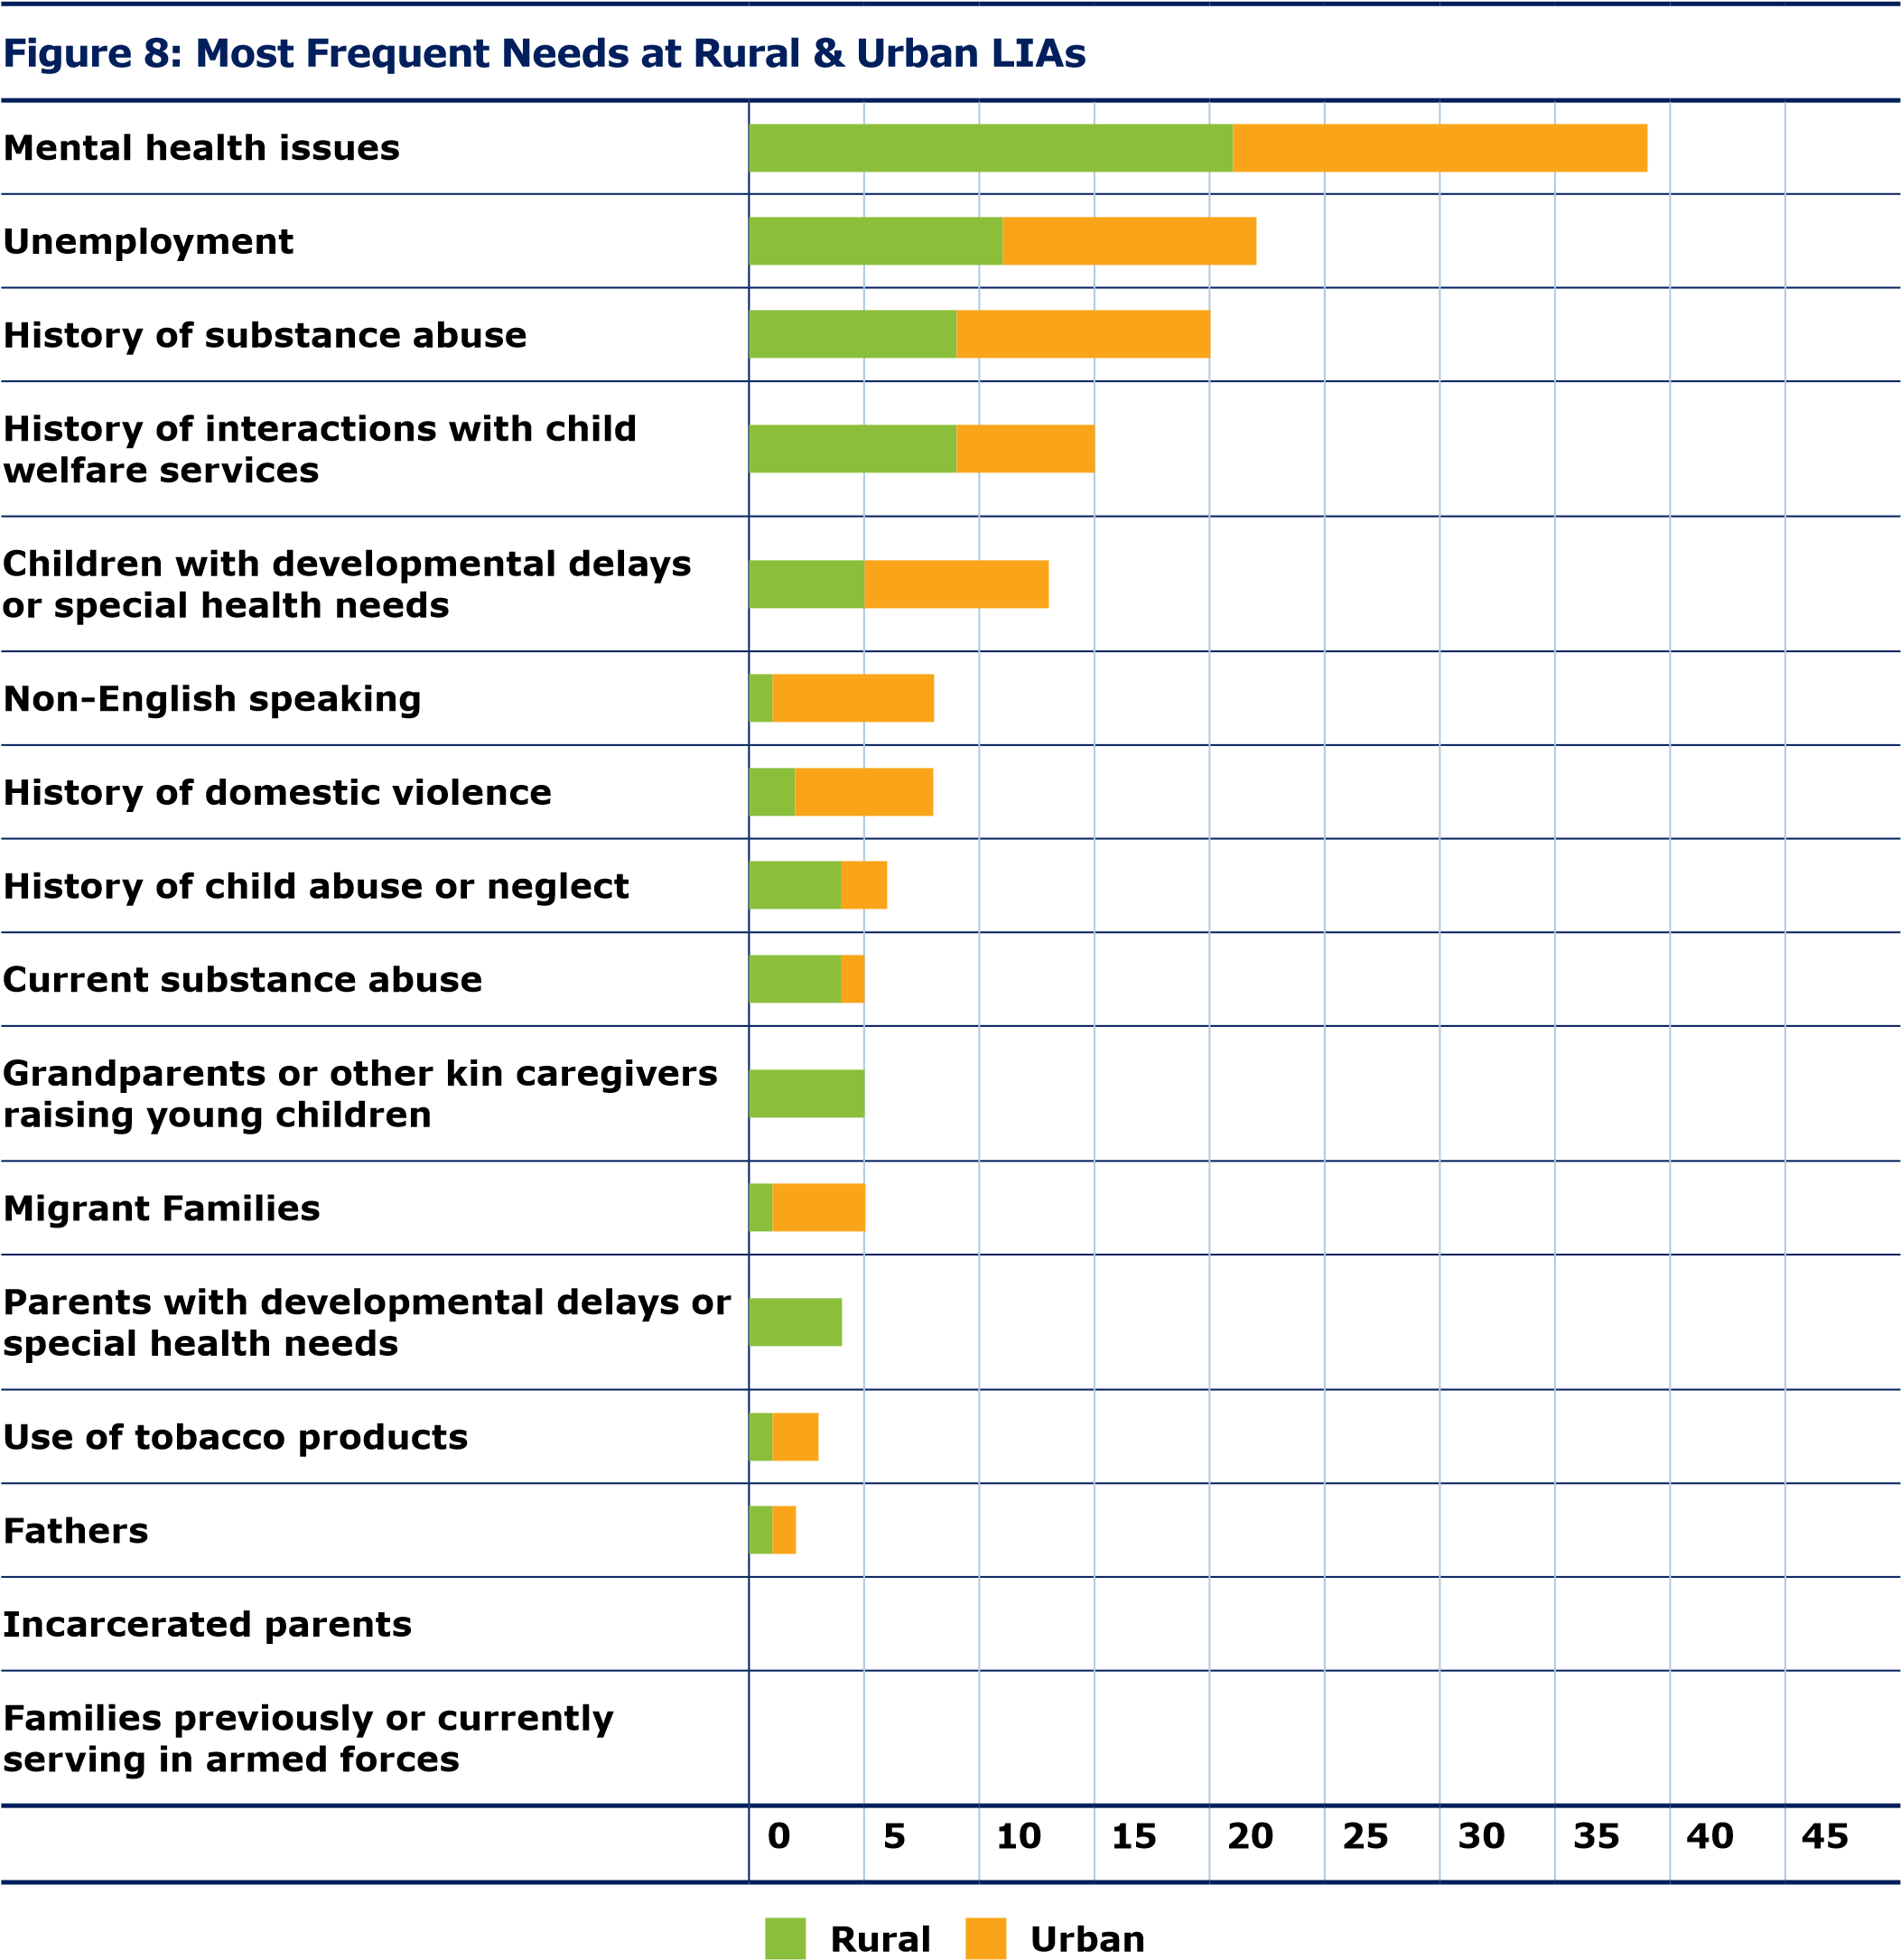

2020 Community Survey
In the fall of 2019, a survey was distributed to communities across the state collecting residents’ views on the availability, quality, and perceived need of services in their community. A total of 2,184 respondents answered the survey, providing a perspective from the state overall and for all six regions in the state (shown in Figure 9). Respondents represented a broad range of demographic groups included home visiting clients (13%), those employed in community-based organizations (28%), those employed in home visiting programs (15%), and those working for county or local government (14%). An additional 30% of respondents were employed in other positions or did not provide a response. The full survey and results can be found in Appendix 7.

FIGURE 9: SURVEY RESPONSE CATEGORIES – SIX REGIONS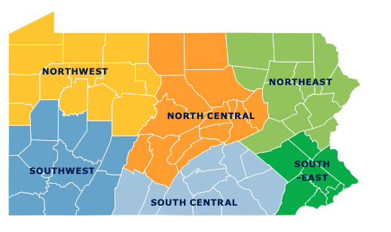
SERVICE AVAILABILITY
The survey asked respondents to consider availability of 12 different services in their community, including: pregnancy and parenting support services, job opportunities for families, infant and toddler child care, children’s health services, and parks, libraries and community centers (Appendix 7). Overall, half of respondents (54%) viewed services in their community as very available or having above average availability. Some services, like pre-K and toddler education services were perceived to be widely available; three-quarters of respondents (77%) assessed these services as very available or having above average availability in their county. Other services were not perceived to have high availability. Only 13% of respondents said that substance use treatment centers were available in their community (shown in Figure 10). Similarly, only 1 in 10 respondents noted wide availability of job opportunities for families. Across all services, there was some regional variability in perceptions of service availability. In particular, the northern part of the state, including the northwest, north central, and northeast regions, consistently reported less availability of services including job opportunities, substance use treatment centers, adult dental care, childcare, children’s health and dental services, health centers, primary care providers and hospitals.

FIGURE 10: PERCENTAGE OF PARTICIPANTS CITING SUBSTANCE ABUSE TREATMENT SERVICES AS BELOW AVERAGE OR NOT AVAILABLE
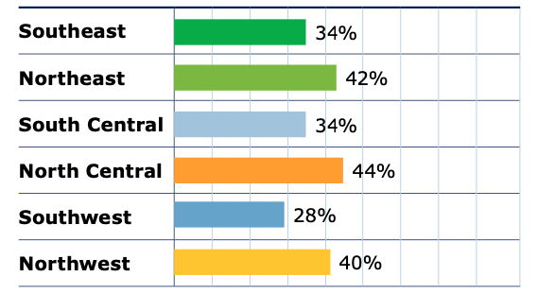

2020 QUALITY OF SERVICES
The survey asked respondents to consider the quality of the same 12 services in their community. Overall, about half (55%) of respondents believed their community offered high- quality or above average-quality services. Some maternal and child services were widely perceived to be of high quality (see Table 15 in Appendix 7). For example, 78% of respondents perceived pre-K and toddler education services to be good or above average quality. Similarly, 60% rated local infant and toddler childcare services as high quality. Once again, the three regions in the northern part of the state reported lower quality of services available in their community, with an emphasis on less high-quality mental health services, substance use treatment services and job opportunities. For example, 38% of respondents from the northwest perceived the quality of their mental health services to be below average or poor. In the northeast, 37% had a similar perception.

2020 Community Need
Respondents were asked to assess their community’s level of need across a range of seven areas: childcare, child safety, community, environment, pregnancy and birth outcomes, social and economic issues and substance use. Respondents noted an overall high level of need for substance use issues (68%), social and economic concerns (63%) and childcare (59%).

2020 Home Visiting Services
A subset of survey respondents (281) included families who received home visiting services. Questions were geared toward their experiences and asked home visiting clients to choose the top five most-valuable home visiting services from a list of 22 common services in evidence-based home visiting programs. Respondents consistently ranked three services as most useful: knowing
if a child is growing or developing normally (54% ranked as a top service), playing to, reading to or teaching children (49% ranked as a top service), and providing resources for pre-K or childcare education (42% ranked as a top service). When home visiting client responses were examined by region, there were some regional differences in the perceived most-valuable services (shown in
Table 16). For example, respondents in the south central region highly ranked having a healthy relationship with their baby (48%) and preventing child injury (45%) as a top home visiting service. Respondents from the northwest were more likely to appreciate home visiting services related to housing assistance and TANF cash assistance.

TABLE 16. TOP-RATED HOME VISITING SERVICES AMONG CLIENTS ACROSS SIX REGIONS IN PENNSYLVANIA.
Please choose the home visiting services that were most useful to you (choose 5).
 | PA | Northwest | Southwest | North Central | South Central | Northeast | Southeast
Knowing if a child is growing or developing normally | 153 | 15 | 29 | 12 | 76 | 9 | 12
 | 58% | 54% | 52% | 55% | 64% | 50% | 31%
Playing to, reading to and teaching children | 137 | 7 | 22 | 12 | 78 | 4 | 14
 | 52% | 25% | 39% | 55% | 66% | 22% | 36%
Pre-K or childcare education resources | 118 | 12 | 25 | 9 | 56 | 4 | 12
 | 45% | 43% | 45% | 41% | 47% | 22% | 31%
Having a healthy relationship with my baby or child | 103 | 7 | 20 | 5 | 57 | 3 | 11
 | 39% | 25% | 36% | 23% | 48% | 17% | 28%
Child safety and preventing injuries | 89 | 6 | 9 | 7 | 56 | 2 | 9
 | 34% | 21% | 16% | 32% | 47% | 11% | 23%
Getting services for a child with  disabilities or special  health care needs | 49 | 6 | 10 | 4 | 14 | 4 | 11
 | 19% | 21% | 18% | 18% | 12% | 22% | 28%
Taking care of a newborn | 45 | 8 | 9 | 1 | 18 | 2 | 7
 | 17% | 29% | 16% | 5% | 15% | 11% | 18%

2020 Overall Health of Mothers and Children
When asked to rank the overall health of mothers and children in their community, over half of all respondents selected either good or excellent health. The perception of availability and quality of services appears to drive perceptions of overall maternal and child health. Similar to prior questions, the southern regions ranked the state of maternal and child health in their community higher than the northern regions (see Figure 11). For example, 52% of respondents from the
northwest, where service availability and quality was perceived to be lower, also rated maternal and child health as fair or poor conditions. In the southeast, where services were reported to be perceived as more prevalent and of higher quality, only 39% of respondents rated maternal and child health as fair or poor.
FIGURE 11. OVERALL RATINGS OF HEALTH OF PREGNANT WOMEN, CHILDREN AND FAMILIES
Please rate the overall health of pregnant women, children and families in your community.
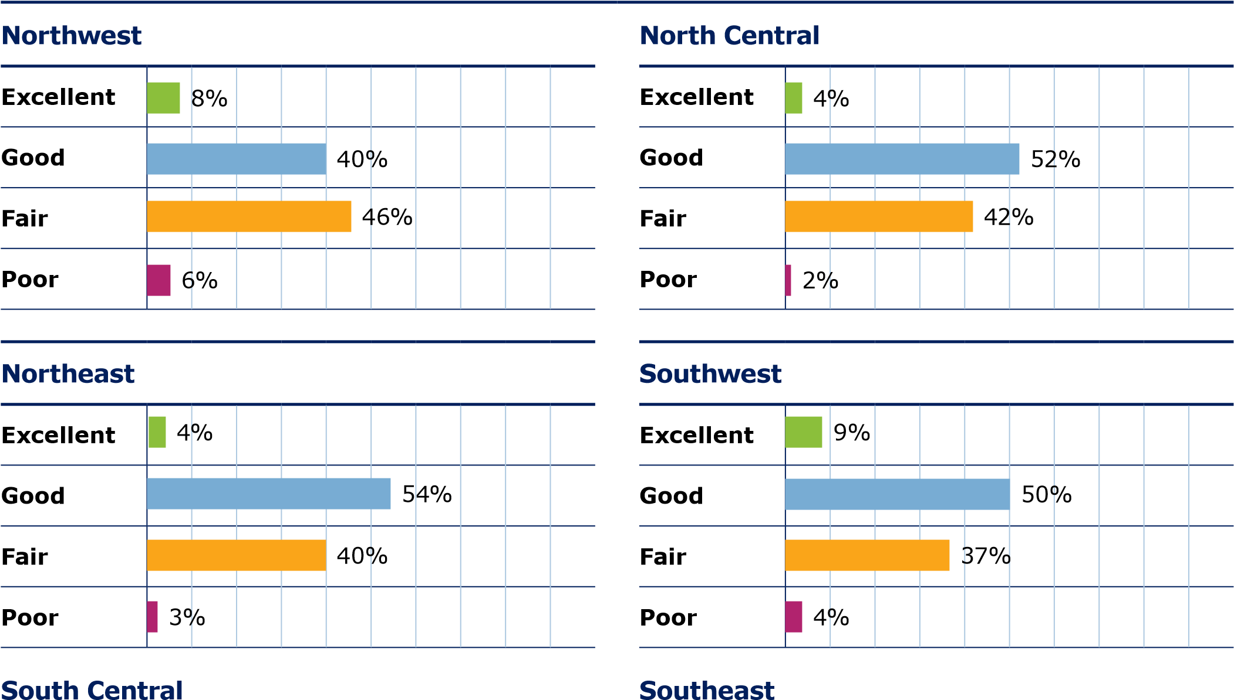
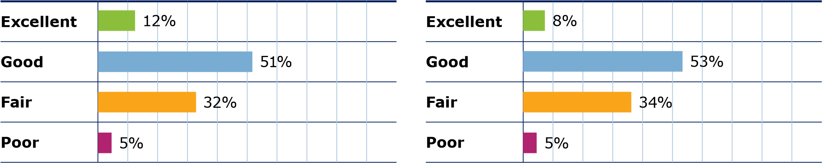

2023 Need (Risk) Factors
To provide an updated analysis of the counties that were determined ineligible for MIECHV funding due to the results of the 2020 Needs Assessment, Pennsylvania utilized the recommended data points provided by HRSA and included a few additional need (risk) factors based on publicly available data. These data points included: Percent of children unserved by EBHV who are under 200% the Federal Poverty Level, low birth weights, infant mortality, child death due to neglect, pregnant women with early and adequate prenatal care, women giving birth who did not smoke during pregnancy, pregnant women who quit smoking by third trimester, and healthy birthweight of birthing parent. County Health Quality of Life factors included child death rate, preterm births, cesarean section births, poverty rate, crime, domestic violence deaths, high school dropouts, unemployment, child maltreatment (both total cases and substantiated cases), drug use disorder, drug overdose deaths, and substance use treatment facilities. These Need (Risk) Factors were analyzed for the 22 counties not currently eligible for MIECHV funding and were compared to all 67 counties in Pennsylvania to determine where each county may have one or more identified need (risk) areas.

2023 Summary of Overall Need for Additional 22 Counties
Counties not Currently eligible for MIECHV Funding per the 2020 Needs Assessment | Average Need (Risk) Level | Count of Need (Risk) Factors above Median | Percentage of Need (Risk) Factors above Median
York | 2.67 | 14 | 66.67%
Wayne | 2.72 | 12 | 63.16%
Berks | 2.42 | 12 | 57.14%
Delaware | 2.53 | 12 | 57.14%
Somerset | 2.45 | 11 | 55.00%
Fulton | 2.50 | 10 | 52.63%
Wyoming | 2.39 | 10 | 52.63%
Northampton | 2.50 | 11 | 52.38%
Franklin | 2.41 | 11 | 50.00%
Elk | 2.53 | 10 | 50.00%
Cumberland | 2.36 | 10 | 47.62%
Lebanon | 2.28 | 9 | 47.37%
Montour | 2.34 | 9 | 47.37%
Lancaster | 2.35 | 10 | 45.45%
Bradford | 2.43 | 9 | 45.00%
Chester | 2.06 | 8 | 38.10%
Westmoreland | 2.47 | 8 | 38.10%
Washington | 2.14 | 7 | 36.84%
Adams | 2.02 | 6 | 30.00%
Montgomery | 1.96 | 6 | 28.57%
Centre | 1.74 | 4 | 19.05%
Butler | 1.73 | 3 | 15.00%

The following counties demonstrated elevated need, above that of Pennsylvania as a whole, by average need (risk) level, or 50% or more of need (risk) factors being above the median for all Pennsylvania counties: Berks, Delaware, Elk, Franklin, Fulton, Northampton, Somerset, Wayne, Wyoming, and York.

In addition, the following counties demonstrated elevated need, above that of Pennsylvania as a whole, in between 33% and 50% of need (risk) factors: Bradford, Chester, Cumberland, Lancaster, Lebanon, Montour, Washington, and Westmoreland.

The following counties demonstrated elevated need, above that of Pennsylvania as a whole, in 30% or less of need (risk) factors, while not demonstrating elevated need overall: Adams, Butler, Centre, and Montgomery. The specific need (risk) factors in which these counties demonstrated need are shown in the table below.

County | Elevated Need Compared to Pennsylvania  For those at 30% or less of Need (risk) Factors
Adams | Percent Unserved in EBHV under 200% Federal Poverty Level | Child Death due to Neglect | Prenatal Health - Pregnant Persons who quit smoking by third Trimester | Poverty | Child Maltreatment- Total Reports | Child Maltreatment - Substantiated Reports
Montgomery | Prenatal Health - Adequate Prenatal Care | Prenatal Health - Pregnant Persons who quit smoking by third Trimester | Child Health - Cesarian Section | Poverty | Crime | Drug Overdose Deaths
Centre | Child Death due to Neglect | Prenatal Health - Weight of Mother | Drug Use Disorder | Drug Overdose Deaths
Butler | Percent Unserved in EBHV under 200% poverty | Poverty | Domestic Violence Deaths
The additional counties not included in the chart above can be viewed in 2023-Appendix 2. Pennsylvania is requesting, based on the data provided and the need (risk) factors for each county, to add the 22 counties that are not currently eligible for MIECHV funding to the eligibility list.

2023 Summary of EBHV Capacity
A Request for Application (RFA) was released on January 11, 2022, with a due date of March 15, 2022. New grant agreements (contracts) began on July 1, 2022. The released RFA can be viewed at the following website:
http://www.emarketplace.state.pa.us/Solicitations.aspx?SID=RFA%2001-22.

All MIECHV Local Implementing Agency (LIA) contracts expired on June 30, 2022, and they were then required to competitively bid for continued funding. Grants awarded though the Request for Application (RFA) process are for a three year period with two optional one year renewals, for a maximum of five years. OCDEL, through the RFA, combined multiple funding sources and programs and the outcome of the competitive procurement decided which LIAs received MIECHV funding to align with funding priorities and requirements. The RFA combined the Commonwealth’s existing Maternal, Infant, and Early Childhood Home Visiting (MIECHV) programs, Nurse-Family Partnership (NFP), Promoting Responsible Fatherhood (PRF), and state funding. The specific objective of the RFA was for the Department of Human Services, Office of Child Development and Early Learning, Bureau of Early Intervention Services and Family Supports to secure the services of qualified applicants to effectively implement and operate community-based high-quality EBHV and enhancements as described in the RFA.

Through the RFA, 16 LIAs were chosen to receive MIECHV funding that now serve 19 counties across Pennsylvania. The models that are MIECHV funded, as of July 1, 2022, are Parents as Teachers, SafeCare Augmented, Nurse-Family Partnership, Early Head Start, Child First, and Family Check-Up. A total of 45 applicants were selected. Pennsylvania has established contracts with those selected through the RFA process.

Pennsylvania also received a large state funded investment of an additional $15 million for all EBHV programs for the July 1, 2022 to June 30, 2023 state fiscal year. An additional $1 million dollar investment was made for the NFP program for a total of $16 million, which was an historic increase in EBHV funding.

Beginning in January 2023, 26 counties were served through MIECHV funds by 22 LIAs. The total capacity of MIECHV funded slots went from 1,372 to 1,635 beginning January 1, 2024, and will go to 1,766 beginning July 1, 2024. In total across all funding streams, as of December 2023, there are 9,784 funded EBHV slots for OCDEL-funded family support programs that provide services in 66 out of 67 counties.

2023 Summary of capacity for providing substance abuse treatment and counseling services.

The mental health and substance use crises are found in every neighborhood and community throughout Pennsylvania. The co-occurring mental health illness and substance use disorders influence each other and present a greater risk for higher morbidity and mortality, increased treatment costs, and a higher risk for homelessness, incarceration, and suicides.

Like many other states, Pennsylvania’s healthcare delivery system is facing increased shortages of providers in vital roles that support people with mental health illnesses and substance use disorders. The COVID-19 pandemic and its impact caused increased and severe mental health challenges, including loneliness, social isolation, acute stress, anxiety, depression, trauma, and loss. This lack of mental health treatment and support for Pennsylvanians, especially our youth and those with intellectual and developmental disabilities and autism, has left emergency departments overwhelmed with people who seek or need a continuum of services, but who are unable to receive timely, affordable, and quality care elsewhere.

There are challenges to finding services, and there is a critical need to seek solutions that adequately address the overarching goals for timely access to mental health and substance use disorder care services and to build capacity for prevention, quality treatment and intervention, and recovery for Pennsylvanians.

Some mental health and substance use statistics specific to Pennsylvania include:
- Suicide is a serious public health problem among all age groups; however, it is the second-leading cause of death among youth, and over half (54.6%) of Pennsylvania’s youth with major depression have not received any mental health treatment.
- Pennsylvania’s Safe2Say Something, a life-saving school safety program allowing for anonymous reporting, received 124,626 tips since the program’s launch and identifies individuals who may be at risk of hurting themselves or others.
- Over half (51.9%) of Pennsylvania’s adults with a mental illness have received no treatment and a quarter (25.7%) of all Pennsylvania’s adults were unable to obtain the treatment they needed.

In October 2023, Executive Order 2023-20 established the Pennsylvania Behavioral Health Council to address the aforementioned mental health and substance use issues. The Council is tasked with developing a statewide action plan that addresses how to deliver timely and quality mental health and addiction care services, in a culturally relevant, trauma-informed, and recovery-oriented manner, through an evidence-based behavioral delivery system; providing recommendations and guidance on how to positively impact the lives of Pennsylvanians with mental health or substance use disorder needs, including what would be required for a resilient behavioral health delivery system; and identifying strategic long-term sustainable investments and policymaking initiatives and recommending concrete actions that could be taken to accomplish those initiatives.

2020 References
Acevedo, A., Panas, L., Garnick, D., Acevedo-Garcia, D., Miles, J., Ritter, G., & Campbell, K. (2018). Disparities in the Treatment of Substance Use Disorders: Does Where You Live Matter? The journal of behavioral health services & research, 45(4), 533–549. https://doi-org.proxy.library.upenn.edu/10.1007/ s11414-018-9586-y

Bidarra, Z. Lessard, G., Dumont, A. (2016), Co-occurrence of intimate partner violence and child sexual abuse: Prevalence, risk factors and related issues, Child Abuse & Neglect, 55, pp.10-21.

Boller, K., Deborah D., Del Grosso, P., Cole, R., Paulsell, D., Hart, B., Coffee- Borden, B., Strong, D., Zaveri, H., and Hargreaves, M. (2014).“Making Replication Work: Building Infrastructure to Implement, Scale-up, and Sustain Evidence- Based Early Childhood Home Visiting Programs with Fidelity.”
Children’s Bureau, Administration for Children and Families, U.S. Department of Health and Human Services. Contract No.: GS-10F-0050L/ HHSP233201200516G. Available from Mathematica Policy Research, Princeton, NJ.

Centers for Disease Control and Prevention (CDC), (2016), Reproductive and Birth Outcomes

Centers for Disease Control and Prevention (CDC), (2017), Pregnancy and Prenatal Care

Centers for Disease Control and Prevention (CDC-a), (2017), Tobacco Use in Pregnancy

Centers for Disease Control and Prevention (CDC), (2018), Infant Mortality: Causes

Centers for Disease Control and Prevention (CDC), (2019), Preventing Child Abuse & Neglect, https://www.cdc.gov/violenceprevention/pdf/CAN-factsheet.pdf

Duggan, A., Portilla, X., Filene, J. Crowne, S., Hill, C, Lee, H., Knox, V.(2018). Implementation of Evidence-Based Early Childhood Home Visiting: Results from the Mother and Infant Home Visiting Program Evaluation. OPRE Report 2018-76A. Washington, DC: Office of Planning, Research, and Evaluation, Administration for Children and Families, U.S. Department of Health and Human Services.

Forray A., (2016), Substance use during pregnancy, F1000Research, 5, F1000 Faculty Rev-887. doi:10.12688/f1000research.7645.1

Giammarise, K. (2020). As record numbers of Pennsylvanians struggle, more ask for help. Pittsburgh Post-Gazette. https://www.post-gazette.com/news/ state/2020/05/24/Pennsylvanians-seek-help-public-programs-food-stamps- Medical-Assistance-CHIP-COVID-19/stories/202005220113

Greene, S., and McCargo, A. (2020). New Data Suggests that COVID-19 is Widening Housing Disparities by Race and Income. Urban Institute. https://www. urban.org/urban-wire/new-data-suggest-covid-19-widening-housing-disparities- race-and-income

Guy, G.P. Jr, Zhang, K., Bohm M.K, et al., (2017), Vital Signs: Changes in Opioid Prescribing in the United States, 2006-2015, MMWR Morbidity and Mortality Weekly Report, 66.

Hamby, S., Finkelhor, D., Turner, H., Ormrod, R. (2010), The overlap of witnessing partner violence with child maltreatment and other victimizations in a nationally representative survey of youth, Child Abuse & Neglect, 34(10), pp.734-741.

Healthy People 2020. U.S. Department of Health and Human Services, Office of Disease Prevention and Healthy Promotion. Available from: https://www. healthypeople.gov/2020/topics-objectives/topic/social-determinants-health/ interventions-resources/housing-instability

Health Resources and Services Administration [HRSA]. Life course approach in MCH. The Division of MCH Workforce Development, HRSA. https://mchb.hrsa. gov/training/lifecourse.asp (18 July 2020),Office on Women’s Health (OWH), (2018), Your Guide to Breastfeeding, www.womenshealth.gov

March of Dimes, (2013), Long-Term Health Effects of Premature Birth, https:// www.marchofdimes.org/complications/long-term-health-effects-of-premature- birth.aspx

March of Dimes, (2016), Alcohol During Pregnancy, https://www.marchofdimes. org/pregnancy/alcohol-during-pregnancy.aspx

March of Dimes (MOD-a), (2017), Preeclampsia, https://www.marchofdimes.org/ complications/preeclampsia.aspx

March of Dimes (MOD-b), (2017), Prescription Opioids During Pregnancy, https:// www.marchofdimes.org/pregnancy/prescription-opioids-during-pregnancy.aspx

March of Dimes (MOD-c), (2018), Low Birthweight, https://www.marchofdimes. org/complications/low-birthweight.aspx

March of Dimes (MOD-d) (2018), Preterm Labor and Premature Birth: Are you at risk?, https://www.marchofdimes.org/complications/preterm-labor-and- premature-birth-are-you-at-risk.aspx

Mayo Clinic, (2017), Premature Birth: Risk Factors, www.mayoclinic.org

McGuire, T. G., & Miranda, J. (2008). New evidence regarding racial and ethnic disparities in mental health: policy implications. Health affairs (Project Hope), 27(2), 393–403. https://doi-org.proxy.library.upenn.edu/10.1377/hlthaff.27.2.393
National Center for Health Statistics (NCHS), (2018), Childhood Mortality Rates, data.cdc.gov
National Council for Behavioral Health. (2020). COVID-19 Economic Impact on Behavioral Health Organizations, https://www.thenationalcouncil.org/ wp-content/uploads/2020/04/NCBH_COVID19_Survey_Findings_04152020. pdf?daf=375ateTbd56

Ohtani, A., Suzuki, T., Takeuchi, H., & Uchida, H. (2015). Language Barriers and Access to Psychiatric Care: A Systematic Review. Psychiatric services (Washington, D.C.), 66(8), 798–805. https://doi-org.proxy.library.upenn. edu/10.1176/appi.ps.201400351

Schiff DM, Nielsen T, Terplan M, et al. Fatal and Nonfatal Overdose Among Pregnant and Postpartum Women in Massachusetts. Obstet Gynecol. 2018 Aug;132(2):466-474. doi:10.1097/AOG.0000000000002734

World Health Organization (WHO), (2014), Global Nutrition Targets 2025: Low Birth Weight Policy Brief
US Census, Federal Reserve Bank Data. Estimated percent of renters who are cost burdened, 2013-2017. PolicyMap. https://plcy.mp/ps36Jbm(16 July 2020).

Warnock, R. & Salviati, C. (2020). Missed housing payments continue piling up in July. Apartment List Survey Data. https://www.apartmentlist.com/research/ july-housing-payments

Xian, M. (2020-a). PA advocates warn isolation during quarantine could lead to increase in domestic violence and abuse. Public Media for Central Pennsylvania. https://radio.wpsu.org/post/pa-advocates-warn-isolation-during-quarantine- could-lead-increase-domestic-violence-and-abuse
Xian, M. (2020-b). Calls to report child abuse dropped significantly since PA coronavirus shutdown began. Public Media for Central Pennsylvania. https:// radio.wpsu.org/post/calls-report-child-abuse-dropped-significantly-pa- coronavirus-shutdown-began

Yun, K., Jenicek, G., & Gerdes, M. (2019). Overcoming Language Barriers in Mental and Behavioral Health Care for Children and Adolescents-Policies and Priorities. JAMA pediatrics, 173(6), 511–512. https://doi-org.proxy.library.upenn. edu/10.1001/jamapediatrics.2019.0400

2023 Amendment References
Shapiro, Josh. “Executive Order 2023-20 – Pennsylvania Behavioral Health Council.” Executive Order, Commonwealth of Pennsylvania, 10 Oct. 2023, www.governor.pa.gov/wp-content/uploads/2023/10/Executive-Order-2023-20-Pennsylvania-Behavioral-Health-Council.pdf

Evidence-Based Home Visiting Enrollment, Pennsylvania Office of Child Development and Early Learning and Early Head Start
https://www.childhoodbeginsathome.org/report/home-visiting-state-county-fact-sheets/

Birth Statistics, Pennsylvania Department of Health
https://www.health.pa.gov/topics/HealthStatistics/VitalStatistics/BirthStatistics/Pages/birth-statistics.aspx

Infant mortality rate per 1,000 live births, Pennsylvania Death Certificates, Pennsylvania Department of Health
https://www.health.pa.gov/topics/HealthStatistics/HealthyPeople/Documents/current/county/mich-02-infant-mortality-rate-lhi.aspx

Child Fatalities / Near Fatalities Reports. Pennsylvania Department of Human Services, Office of Children Youth and Families
https://www.dhs.pa.gov/docs/Publications/Pages/Quarterly-Summaries-Child-Abuse.aspx

Resident live births by age of mother, birth weight, and year of birth 2021. Pennsylvania Department of Health
https://www.health.pa.gov/topics/HealthStatistics/VitalStatistics/BirthStatistics/Pages/birth-statistics.aspx

Percent of pregnant females with early and adequate prenatal care, Pennsylvania Department of Health
https://www.health.pa.gov/topics/HealthStatistics/HealthyPeople/Documents/current/county/mich-08-percent-of-pregnant-females-with-early-and-adequate-prenatal-care.aspx

Percent of females who reported smoking in the first or second trimester that quit smoking by their third trimester, Pennsylvania Department of Health
https://www.health.pa.gov/topics/HealthStatistics/HealthyPeople/Documents/current/county/tu-15-percent-of-females-who-quit-smoking-by-their-third-trimester.aspx

Percent of females giving birth who did not smoke during pregnancy, Pennsylvania Department of Health
https://www.health.pa.gov/topics/HealthStatistics/HealthyPeople/Documents/current/county/mich-10-percent-of-females-giving-birth-who-did-not-smoke-during-pregnancy.aspx

Percent of mothers with a healthy weight before giving birth, Pennsylvania Department of Health
https://www.health.pa.gov/topics/HealthStatistics/HealthyPeople/Documents/current/county/mich-13-percent-of-mothers-with-a-healthy-weight-before-giving-birth.aspx

County Health Ranking and Road Maps, Environmental Factors 2023
Pennsylvania Birth Certificate, Pennsylvania Fetal Death Certificate Dataset, and Pennsylvania Induced Abortion Dataset
https://www.countyhealthrankings.org/explore-health-rankings/pennsylvania?year=2023

Child and adolescent death rate per 100,000 aged 1 to 19, Pennsylvania Department of Health
https://www.health.pa.gov/topics/HealthStatistics/HealthyPeople/Documents/current/county/mich-03-child-and-adolescent-death-rate-aged-1-to-19.aspx

Percent of live births which are preterm (less than 37 weeks gestation), Pennsylvania Department of Health
https://www.health.pa.gov/topics/HealthStatistics/HealthyPeople/Documents/current/county/mich-07-percent-of-live-births-which-are-preterm.aspx

Percent cesarean section births 2016-2020, Pennsylvania Department of Health
https://www.health.pa.gov/topics/HealthStatistics/VitalStatistics/CountyHealthProfiles/Documents/current/index.aspx#download-statistics

Pennsylvania Poverty Rate by County, Index Mundi
https://www.indexmundi.com/facts/united-states/quick-facts/pennsylvania/percent-of-people-of-all-ages-in-poverty#chart

Crime Offense Density Report, Pennsylvania Uniform Crime Reporting System
https://www.ucr.pa.gov/PAUCRSPUBLIC/SRSReport/CrimeDensity

2022 Fatality Report, Pennsylvania Coalition Against Domestic Violence
https://www.pcadv.org/wp-content/uploads/2022-Fatality-Report.pdf

2021-22 School Dropout Rate, Pennsylvania Department of Education, Division of Data Quality
https://www.education.pa.gov/DataAndReporting/Dropouts/Pages/default.aspx

November 2023 Unemployment Data, Pennsylvania Center for Workforce Information & Analysis
https://www.workstats.dli.pa.gov/Products/CountyProfiles/Pages/default.aspx

2022, Calendar Year, Child Maltreatment Reports and Substantiated Reports, Pennsylvania Office of Children, Youth, and Families
https://www.dhs.pa.gov/docs/OCYF/Documents/2022-PA-CHILD-PROTECTIVE-SERVICES-REPORT_8-10-2023_FINAL.pdf

2020 Drug Use Disorder - All (12 to 100 years), Open Data PA
https://data.pa.gov/stories/s/Pennsylvania-Opioids/9q45-nckt/

2022 | Any Drug Overdose Deaths by County excluding alcohol only related overdoses, Pennsylvania Office of Drug Surveillance and Misuse Prevention
https://public.tableau.com/app/profile/pennsylvania.pdmp/viz/PennsylvaniaODSMPDrugOverdoseSurveillanceInteractiveDataReport/ED-Demographics

2018, Drug and Alcohol Treatment Facilities, Open Data PA
https://data.pa.gov/stories/s/Treatment/fvkx-eumb

March 2023 - Estimated Population, U.S. Census Bureau, Population Division
Annual Estimates of the Resident Population for Counties in Pennsylvania: April 1, 2020 to July 1, 2022 (CO-EST2022-POP-42)
https://www.census.gov/data/tables/time-series/demo/popest/2020s-state-total.html

