Year 1 Monitoring
ORIENTATIONS / SITE VISIT
The grantee shall attend a scheduled orientation(s) after notification of award. The grantee shall participate in professional trainings as required by the National model developer(s), and training including, but no limited to an orientation series and ongoing professional development through OCDEL.
- Program Orientation
- Data System Orientation
- Fiscal Orientation
- Strengthening Families Protective Factors Framework (SFPF) Orientation

Did the grantee have a representative attend the orientation webinar(s)?
☐ Yes | ☐ No, please explain below

POLICIES AND PROCEDURES – Confidentiality
The grantee will establish a Confidentiality Policy; requirements specified in the grant agreement and/or the Policy and Procedure Manual.

The agency has developed a Confidentially Policy that meets all requirements
☐ Yes | ☐ No, please explain below
POLICIES AND PROCEDURES - Early Intervention
The grantee will coordinate services with Early Intervention agencies. This coordination will be documented through the establishment of a MOA/U that meets the requirements specified in the grant agreement and/or the Policy and Procedure Manual. Does the Agency share the results of the ASQ screening with the EI agency? Does the Agency also complete the ASQ-SE? Does the Agency share the results of the ASQ SE with the EI agency? Note: May not apply to CTF grantees serving families with older children.

The agency has developed a MOA/U with EI that meets requirements specified in guidance (Announcements and Policy and Procedure Manual)
☐ Yes | ☐ No, please explain below

POLICIES AND PROCEDURES – Local Home Visiting and Family Support Agencies
The grantee agrees to obtain an MOU and/or MOA with other local home visiting and family support service providers in the communities/county or counties that the grantee serves. MOU/A meet the requirements specified in the grant agreement and/or the Policy and Procedure Manual.

The agency has developed a MOU/MOA with other local home visiting providers that meets all requirements
☐ Yes | ☐ No, please explain below

POLICIES AND PROCEDURES – Reflective Supervision
The grantee shall implement high-quality supervision, including reflective supervision for EBHV staff. Grantees must develop and implement policies and procedures that are delivered effectively program-wide and with fidelity to the model(s) implemented.

The agency has developed has policies and procedures of the reflective supervision process with staff.
☐ Yes | ☐ No, please explain below

POLICIES AND PROCEDURES –Intake Process / Informed Consent
The grantee will develop implement policies and procedures to accept referrals in to the EBHV program(s). The policies and procedures will include a process to enroll eligible families in a model that best meets their needs and avoids dual enrollment. Policies and procedures will also describe how caseloads are covered when staff leave. The policies will note that families and their children are willingly volunteering for the provided Family Support Programs, including EBHV Models, Enhancements, and associated services as described in the grantees work statement. The Grantee includes in their policies how they will train home visitors and family support staff on informed consent for families.

The agency has developed has policies and procedures of the intake process that meets all requirements
☐ Yes | ☐ No, please explain below

RELATIONSHIP WITH MODEL DEVELOPERS
The grantee has established a relationship with the model developer(s).

☐ Yes | ☐ No, please explain below

FIDELITY TO MODEL
The grantee is implementing their chosen model(s) with fidelity.

☐ Yes | ☐ No, please explain below

CQI (Existing Programs already implementing CQI that rolled over from a previous grant award)
The grantee has developed a CQI plan around a need identified by the assessment, by the Performance Measures, or by a local need identified by the grantee. The grantee is submitting the required CQI reports timely. *Does not apply to CTF*

☐ Yes | ☐ No, please explain below

DATA REPORTING
The grantee is following appropriate data reporting timelines and standards. Data reports are accurate. Missing data is at a minimum. The grantee is utilizing the Family Support Data System as required.

☐ Yes | ☐ No, please explain below

ENROLLMENT
The grantee will maintain at enrollment between 90%-100% of the budgeted capacity for each EBHV Model implemented. Family Support Programs are required to serve at least 80% of the approved goal number of families.

The grantee maintained the appropriate enrollment based on the capacity of the EBHV program and/or Family Support goal number.
☐ Yes | ☐ No, please explain below

OCDEL ANNOUNCEMENTS
The grantee has complied with any OCDEL Announcements released this fiscal year. All relevant announcements are listed below.

☐ Yes | ☐ No, please explain below

FEDERAL FUNDING PROGRAM AND FISCAL REQUIREMENTS (if applicable)
The grantee has reviewed any relevant program and fiscal requirements if receiving federal funding as a portion or the entirety of their award. For Fiscal Requirements please see Appendix A. The grantee is in compliance with the federal funding and program requirements.

☐ Yes | ☐ No, please explain below

ADDITIONAL COMMENTS
Please use this space to note any additional comments if necessary.

For the Monitoring Tool & On-Site Guide:

http://www.pa-home-visiting.org/providers/#Templates

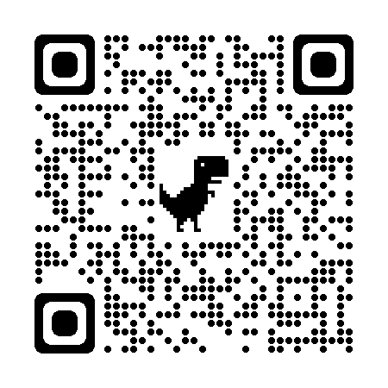

Reporting Year:
☐ Year 1 (2022-2023) ☐ Year 2 (2023-2024) ☐ Year 3 (2024-2025) ☐ Year 4 (2025-2026) ☐ Year 5 (2026-2027)

Quarterly Reports | 1 |  |  | 2 |  |  | 3 |  |  | 4
Quarterly Program Report
Quarterly Expenditure Report
Quarterly Staffing Report
Monthly Reports | J | A | S | O | N | D | J | F | M | A | M | J
Monthly Enrollment Report (By 15th)
Monthly PDSA (CQI) – 18th
Data Entry (By 10th)
Calls with Programs (Dates)
YEARLY REPORTS
CQI Team Plan – August 31st
CQI Summary Report – Within 30 days of end of CQI Project
GL Reconciliation
Fiscal Audit
Grant Renewals
TWICE A YEAR
CTF Outcomes Report
NOTES

